Software Engineering Logbook Scaffold
A Comprehensive Structure for Consistent and Clear Documentation
Introduction 1
Purpose of the Logbook 1
Core Sections of the Logbook Scaffold 1
1. Daily Log Entries 1
Best Practices for Maintaining a Logbook 1
Sample Logbook Entry Example 2
Logbook Scaffold: 4
Logbook Entries: 5

Introduction
A software engineering logbook is a critical tool for professionals and students alike, serving as a detailed chronicle of progress, challenges, decisions, ideas, and learnings throughout the lifecycle of a software project. Properly maintained, a logbook enhances communication, supports reproducibility, facilitates teamwork, and provides a valuable historical record for future reference.

Purpose of Part A Logbook
The entries of this logbook should focus on your decision making surrounding the design of the project and how you have completed each section of the task.

Core Sections of the Logbook Scaffold

1. Daily Log Entries
- Date: 8/1/26
- Entry Author: Fred Gaffey
- Image of changes: Supporting image(s) of documents or code associated with contents of log
- Summary of Activities: Detailed account of work done, including coding, testing, research, debugging.
- Challenges Encountered: Issues, bugs, roadblocks, misunderstandings.
- Solutions and Actions Taken: How were the challenges addressed? What was tried and what worked?
- Learnings: Insights or new knowledge gained.
- Next Steps: Planned actions for the subsequent sessions.
- Code Snippets: Reference, describe, and annotate key pieces of code (avoid dumping large code blocks).
- Version Control Activity: Record commits, branch merges, tagging, and repository organization.

Best Practices for Maintaining a Logbook
- Update Regularly: Log entries should be made daily or immediately after significant work sessions.
- Be Detailed, Yet Concise: Capture enough context to be useful, but avoid unnecessary verbosity.
- Use Clear, Unambiguous Language: Especially when describing problems or decisions.
- Attach or Reference Supporting Materials: Diagrams, screenshots, code snippets, or related documents.
- Keep Logbooks Organized: Use clear headings, bullet points, and date stamps for easy navigation.
- Review and Reflect: Regularly revisit previous entries to identify patterns, risks, and areas for improvement.

Sample Logbook Entry Example
Date: | 22/08/2025
Title: | Integrating Database Functionality for DogMatch Web App
Author: | [Your Name]
Tasks Description: | Implemented a PostgreSQL relational database to store user profiles, dog details, match history, and messaging data. Established secure connections between the web app backend (Node.js/Express) and the database, created schema, and configured ORM (Sequelise) for data modeling and queries.
Image: | 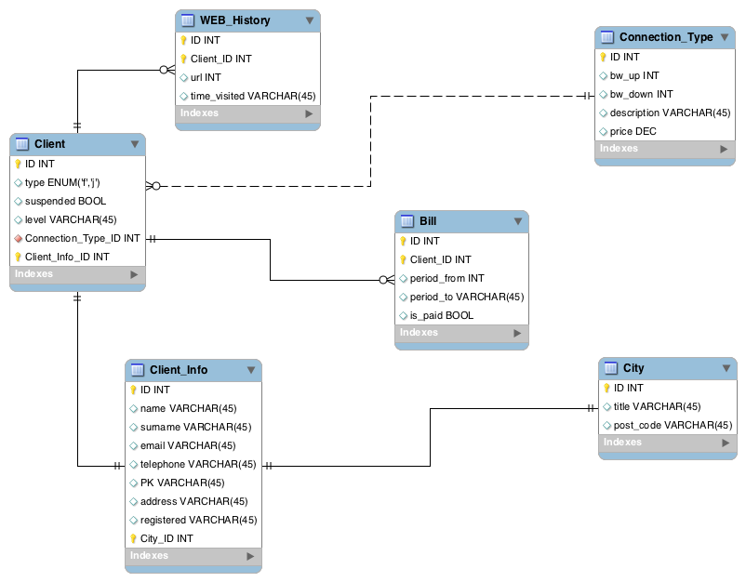e
Logbook Entry: | - Summary of Activities: Today, I architected and deployed an initial database layer for the DogMatch web application—our “Tinder for Dogs.” The focus was to ensure scalable storage for user accounts (owners), dog profiles (name, breed, age, photos, bio), swipes/likes (match history), and in-app chat messages. I set up a PostgreSQL instance, designed normalized tables, and implemented associations (one-to-many: user to dogs; many-to-many: dogs to matches).  - Challenges Encountered: I faced difficulty maintaining data consistency when deleting user accounts—cascade deletions across linked dog and match records were initially not functioning as expected. Additionally, optimizing queries for retrieving potential matches (excluding already-swiped profiles) required refining SQL logic.  - Solutions and Actions Taken: Implemented ON DELETE CASCADE in table relationships and updated Sequelise models to reflect proper associations. For matches, I constructed a subquery-based filter to efficiently exclude previously swiped dogs from query results.  - Learnings: Gained hands-on experience with designing relational data for social matching applications. Understood the importance of data modeling for scalability and the efficiency gains from using ORMs like Sequelise, but also the necessity of direct SQL for complex queries.  - Next Steps: Integrate authentication, refine validation on profile creation, and optimize database indices for common search fields (breed, age, location). Plan to develop unit tests for database transactions and begin work on a data backup strategy.

Logbook Scaffold:
Copy this tables as a scaffold for each of the logbook entries. You should copy this for each new logbook entry, which will be entered into the next section.
Date:
Title:
Author:
Tasks Description:
Image:
Logbook Entry: | Progress since the last entry:  Task Achieved:  Stumbling blocks or issues encountered and how they were managed:  Possible approaches for upcoming tasks:  Reflective comments:
Resources:

Logbook Entries:
Date: | 8/1/26
Title: | Worked out how to do Ollama integration make a basic app
Author: | Freddy Gaffey
Tasks Description: | I downloaded the ai model  Made a basic flaks app that I can ask a ai a question and it will give me a answer to a question.
Image: | 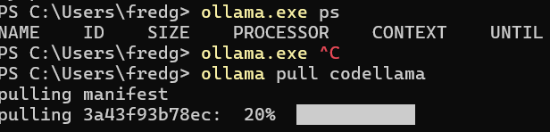  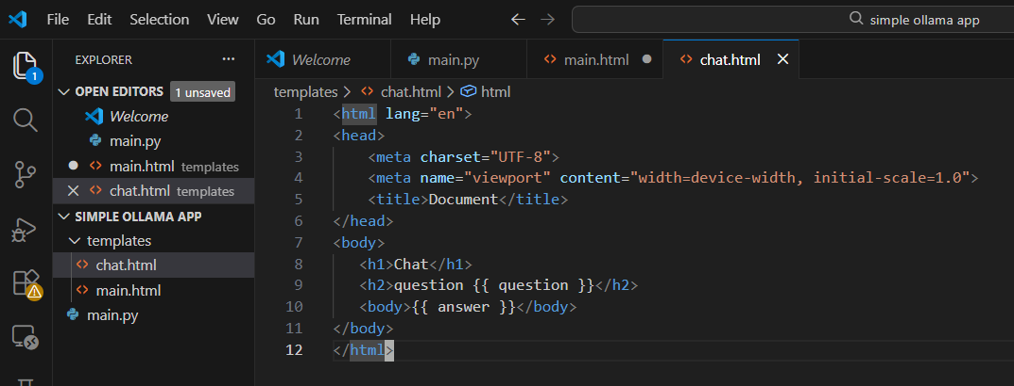  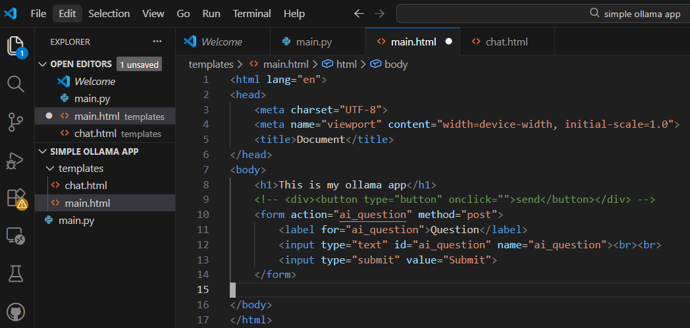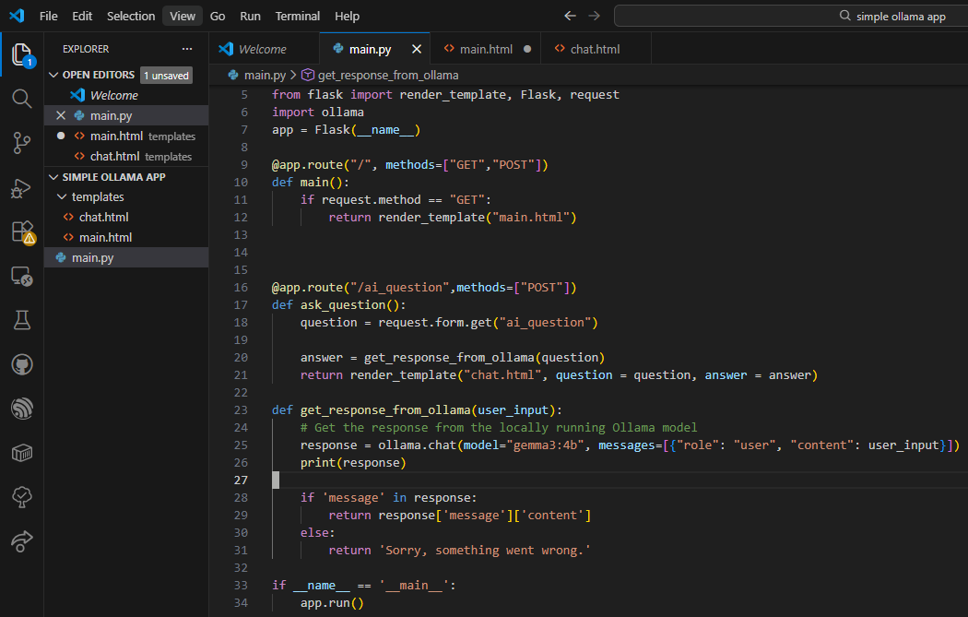  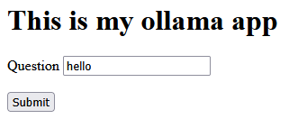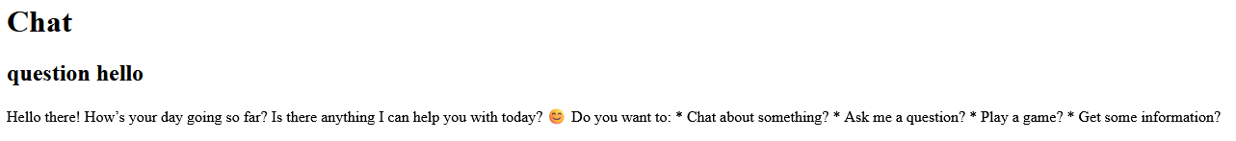
Logbook Entry: | Progress since the last entry: made a whole basic flask app  Task Achieved: This is just to gain familiarity with flask and HTML. Maybe the code will be reusable later in the project.  Stumbling blocks or issues encountered and how they were managed: I had a form tag in the wrong spot.  Possible approaches for upcoming tasks: N/A  Reflective comments: This was a great learning experience but I might have to use a bigger computer or cloud compute if I am to have lots of users
Resources: | https://www.w3schools.com/tags/tag_form.asp  https://www.codewithfaraz.com/python/112/how-to-create-your-own-ai-chatbot-like-deepseek-with-ollama-in-python-flask

Date: | Jan 24, 2026
Title: | Start work on the esp32 server and its architecture
Author: | Freddy Gaffey
Tasks Description: | Made pseudocode for the server architecture  Make a it create a wifi ap and also connect to home wifi  Init platform io
Image: | 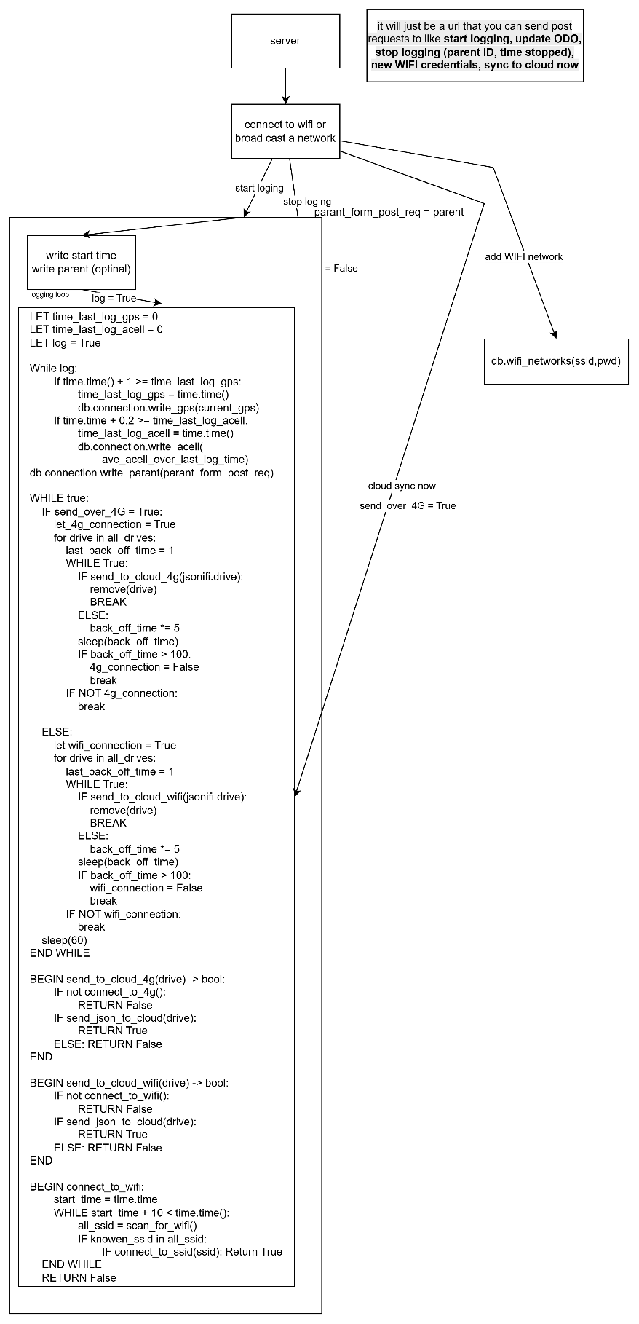
Logbook Entry: | Progress since the last entry: The progress the last entry was that I got a working ESP 32 to connect to Wi-Fi networks and I also worked out the overall system architecture of how the ESP 32 will work  Task Achieved:  got platform IO setup  worked out the architecture of the ESP 32 system  got the ESP 32 connect to Wi-Fi networks and start a simple web server  Stumbling blocks or issues encountered and how they were managed:  Initially I was intending to use Arduino but as we know takes so long to compile and doesn't have the most enjoyable developer experience so halfway through I switched to platform IO and that led to faster compile times better auto completion and because platform IO is a VS code extension it was much more familiar  Possible approaches for upcoming tasks:  I think I'd want to move a lot of the Wi-Fi stuff to a separate folder and then I can have multiple sort of utility files for Wi-Fi SD card GPS etc and then what I can do is in the main file I could just call them and I might also set up a separate file for logging  Reflective comments:  This is my first time writing C++ code properly so it was a bit of a learning curve but there was lots of very good examples online and I also got AI to help me debug my code although because I was learning C++ I made a particular effort not to copy any code directly from anywhere I would always type it out myself so that I would start building the muscle memory.
Resources: | https://github.com/me-no-dev/ESPAsyncWebServer/wiki  https://www.arduino.cc/reference/en/libraries/wifi/  https://www.claude.com/ I asked lots of questions about how to get pointers to work how variable initialisation works how does inheritance in classes work and types and casting and other stuff like that. Also I sometimes used it to translate the C++ code into Python code so it would be easier for me to understand it

Date: | Jan 28, 2026
Title: | Started implementing logging and the fsm which is how it works
Author: | Freddy Gaffey
Tasks Description: | Start to define the state machine architecture  make mocks for the sensors
Image: | 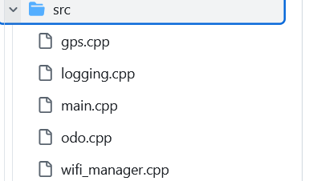  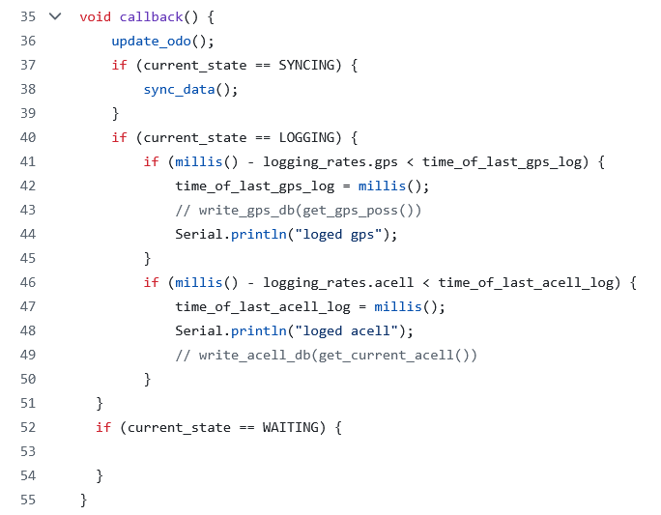  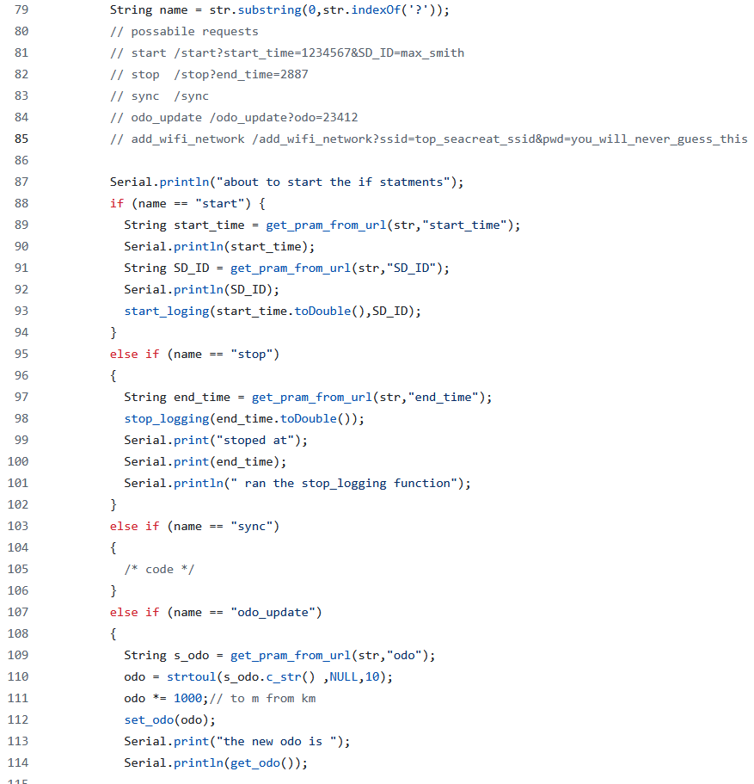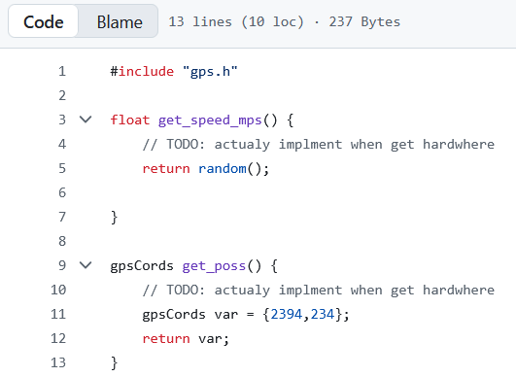
Logbook Entry: | Progress since the last entry:  Implemented more of the state machine architecture as well as defining some mocks also worked out the API endpoint for the server and because of the way I designed it I also developed a parser for passing the URLs into strings so that it would be a convenience function  Task Achieved:  implemented substantially more the finite state machine  did some URL passing and worked on the API endpoints on the server  split things up into different files to make finding code easier and to improve readability  Stumbling blocks or issues encountered and how they were managed:  I didn't know what a .h file was and this is an important file which basically allows you to import code from another file and you need to have this but I didn't know that they were needed so I was trying to import C++ code and getting errors.  It took me a couple attempts to arrive on the callback architecture that I am currently using  Possible approaches for upcoming tasks:  I will need to get some actual hardware so that I can read from So that I can replace my mocks with actual hardware  also I need to working out a significant problem about how to deal with the limitations on browsers unable to let you go from a HTTPS but send a request to an HTTP endpoint.  Reflective comments:  I'm at the point where I've written about 300 to 400 lines of C++ code and I'm finally getting the hang of it is such a different language to Python but I kind of like it
Resources:

Date: | Commits on Jan 29, 2026
Title: | Working out how to get around the HTTPS to HTTP restrictions
Author: | Freddy Gaffey
Tasks Description: | work out how to get around the HTTPS to HTTP restrictions
Image: | There was not much research for this I just spent a lot of time working out trying how to bypass it and every time I had an idea I would use a ai to Fact Check it and to point out the holes in it. Initially I attempted to use CORS but I found out that that would not work because it was being blocked at a lower level.  Then I had the idea of using image tags to essentially request an image from the server and that request could be logged as a starter stop depending on if it requested the start image or stop image this approach is also very hacky and I didn't like it  I also looked in to self signing but it was painful and also a bad UX  I finally decided to use a redirect which lets me Send the user to a site and give them a post request and then I could either let the ESP host the website that has the functionality for logging or I could have it immediately redirected back to the main server and I can also pass in parameters in map post request. But either one of these approaches was feasible and I did not have to now integrate 4G into the L plate have the server sender request to it to start logging and stopping this also gives me offline functionality  Then I used ngrok To host a basic flask PWA I did not write this one myself cause it was not my project I just wanted to validate that PWA way hosted via HTTPS could send a redirect to http website on a local network and it could.  The app code is at 85530ddd3099afc55b22ca76afbb071c9029acae  The esp 32 code is at dbb784d0ca424ba391ff5f7d928fd00ea894bb2d
Logbook Entry: | Progress since the last entry:  I successfully validated one of the fundamental principles of how my project will work.  Task Achieved:  I managed to send redirect from a cloud hosted HTTPS PWA to a locally hosted HTTP server running on the ESP 32 then the ESP 32 was able to redirect back to the cloud-hosted PWA website wow disconnected from the server.  Stumbling blocks or issues encountered and how they were managed:  I mentioned them in the image box  Possible approaches for upcoming tasks:  There is 2 approaches to how I could handle the control of the I could either have the ESP 32 host the UI for start and stop. Or I can have the PWA contain the UI controlling logging and have the PWA redirect the user to the ESP in the ESP redirect back to PWA as fast as possible.  Reflective comments:  I WISH I COULD JUST SEND A GET REQUEST!!! This I absolutely ridiculous
Resources: | https://blog.appmysite.com/what-is-a-progressive-web-app/  https://www.youtube.com/watch?v=wQgx5Pou44s  https://web.dev/learn/pwa  https://hnpwa.com/  https://developer.mozilla.org/en-US/docs/Web/Progressive_web_apps/Tutorials  https://www.youtube.com/watch?v=sFsRylCQblw Progressive Web Apps in 100 Seconds // Build a PWA from Scratch : Fireship  https://developer.chrome.com/docs/workbox/  https://github.com/elegantapp/pwa-asset-generator  HOW TO COMMUNICATE TO THE ESP 32  https://stackoverflow.com/questions/53211319/how-can-i-make-an-http-request-from-an-https-website my fist idea was to have the esp 32 host a server that acts as a API endpoint but this can’t work because mixed content (having https and http) is unsafe so I need to find a way around that.

Date: | Jan 30, 2026
Title: | Writing a SD card in GPS hardware mock
Author: | Freddy Gaffey
Tasks Description: | I made a separate file for a SD card which would basically let me pass in a GPS instance and a speed and it would write to the current SD card log file the GPS data and time
Image: | 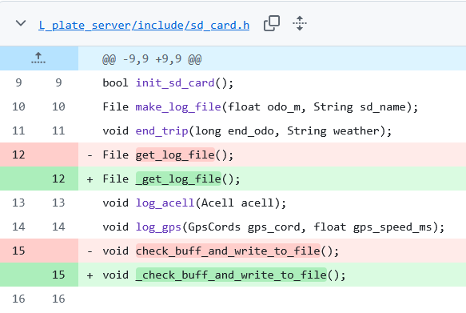  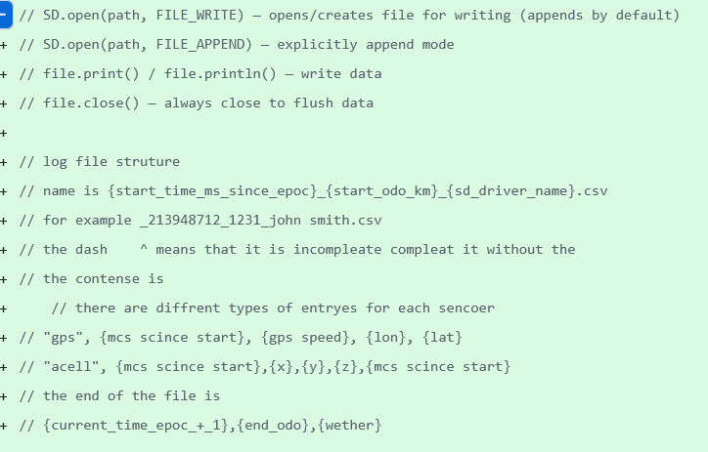  This ^^^ is the log file structure  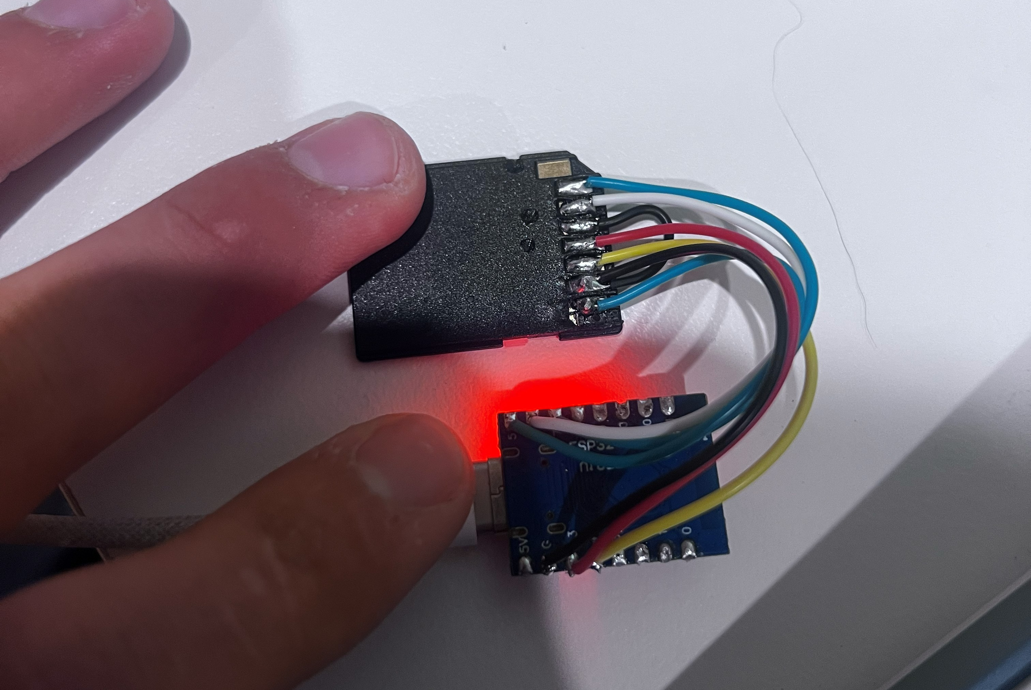  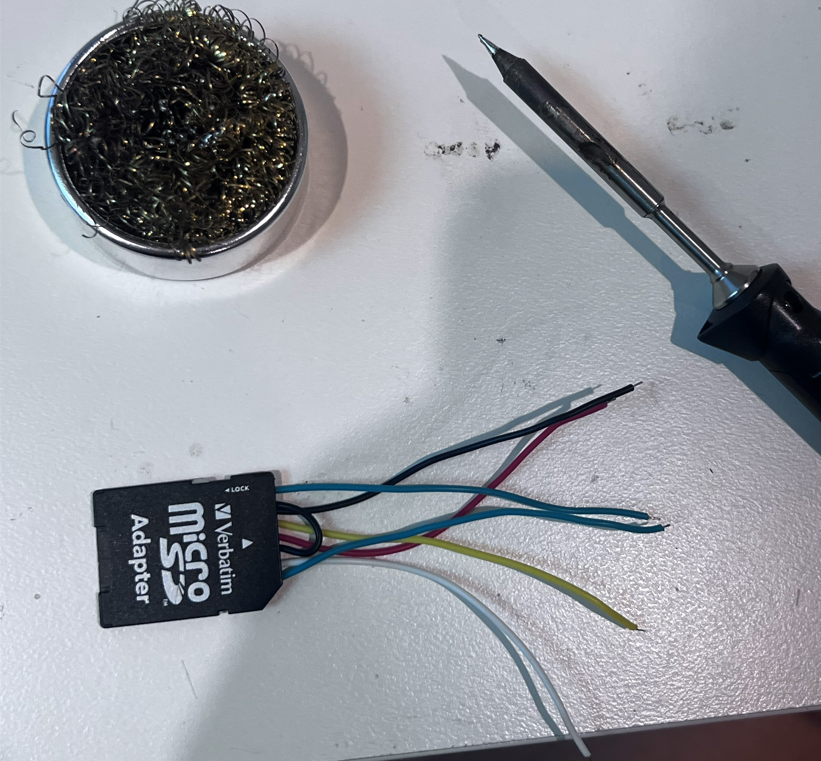
Logbook Entry: | Progress since the last entry:  I designed a log file format  Make some of high level functions such as logging data starting trips ending trips  Task Achieved:  Making high level functions for updating the log files as well as I fix some minor bugs in the Wi-Fi class  I also connected a SD card too my ESP 32  Stumbling blocks or issues encountered and how they were managed:  this file took me a couple of attempts to write because I initially had the wrong approach and I was passing files too much and this had bad performance as this is only running on a small microcontroller so I instead implemented the buffer system where I write to a buffer in memory and then once that buffer overflows (not a buffer overflow it's a string type so it can be written to past a certain point) I will cash it to the SD card.  Possible approaches for upcoming tasks:  I need to check that the rest of this class has enough performance to run at a 10 HZ if needed.  Reflective comments:  Designing a my own csv was fun but passing it will not be have fun future me
Resources: | https://github.com/espressif/arduino-esp32/blob/master/libraries/SD/README.md this was really helpful  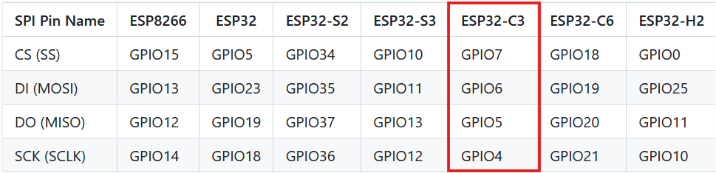  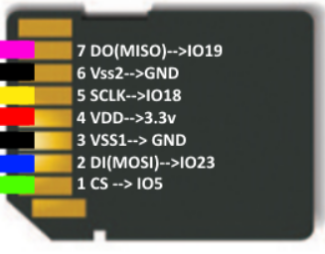

Date: | Jan 31, 2026
Title: | Setting up host name and bug fixes
Author: | Freddy Gaffey
Tasks Description: | Conduct testing on whether the logging actually works and resolve any of those bugs that occur.  Setup host name so that it can be redirected is easier
Image: | 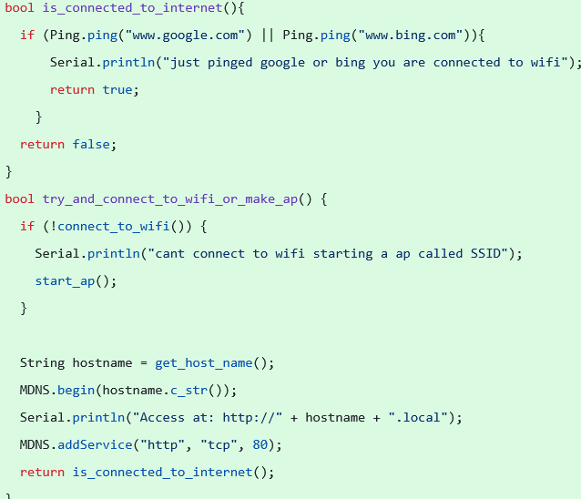  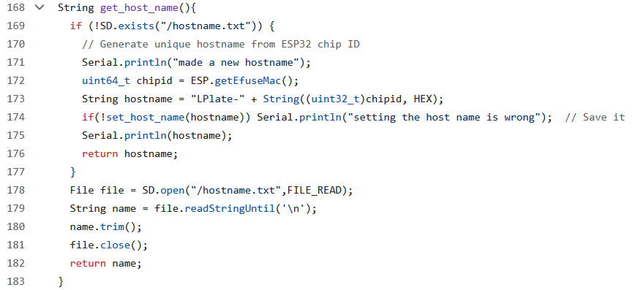  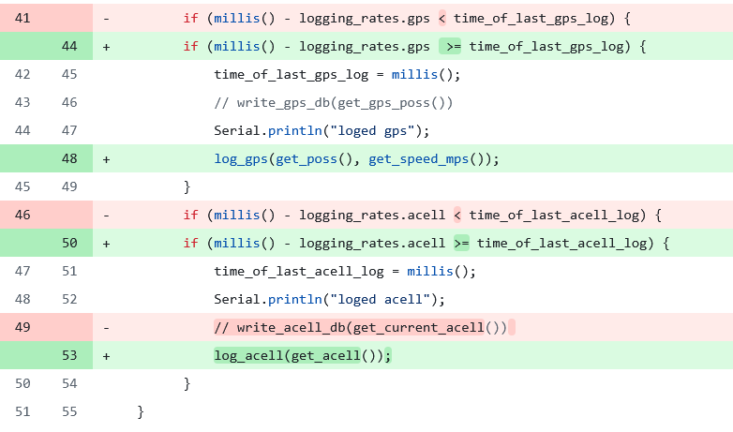  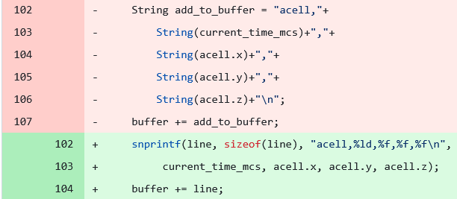  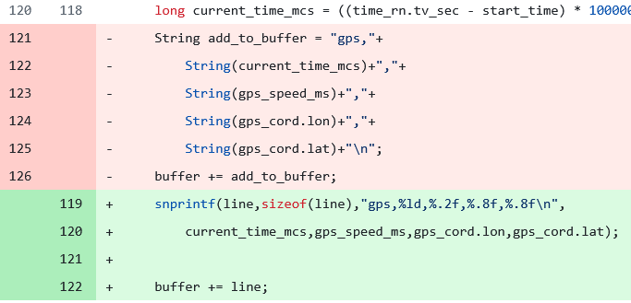  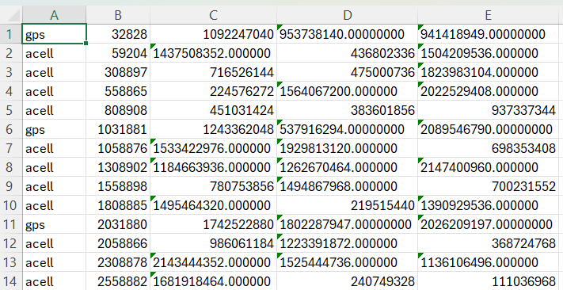  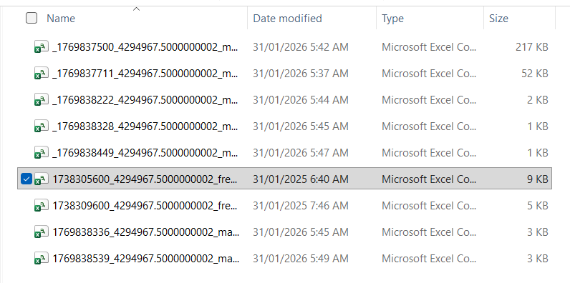  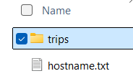
Logbook Entry: | Progress since the last entry:  Implemented checks see if connected to the internet  Made host name configurable by the user by editing the SD card  Bug fixes  Task Achieved:  Have a working host name  Check if connected to the internet by pinging Google.  I used snprintf instead of creating mutable string objects and then concatenating them as it was significantly slowing down performance but now let me run the loop.  Also I fixed some logical errors in logging rate  The L plates logging functions work now  Stumbling blocks or issues encountered and how they were managed:  I Initially had some quite bad performance issues but I fixed them by using more low level memory allocation as well as caching then writing in one go  Possible approaches for upcoming tasks:  I need to determine whether I will have a esp based controller or a play PWA based controller  Reflective comments:
Resources:

Date: | Jan 31, 2026
Title: | Start the main PWA
Author: | Freddy Gaffey
Tasks Description: | imported the code from ed stem  defined my database schema
Image: | 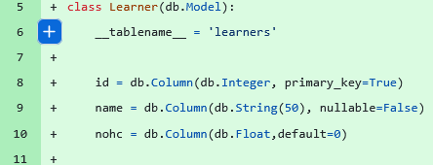  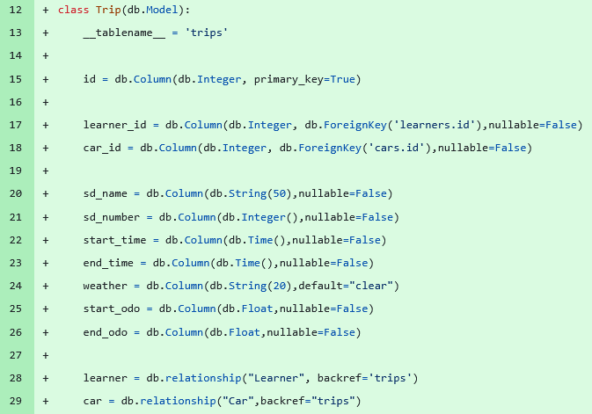  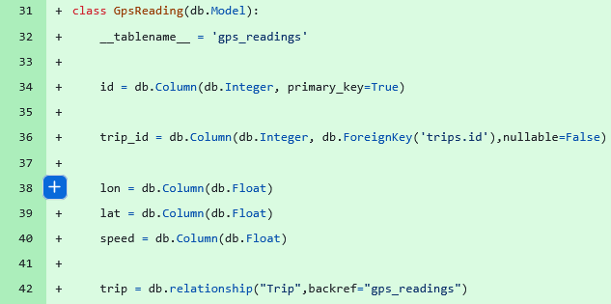  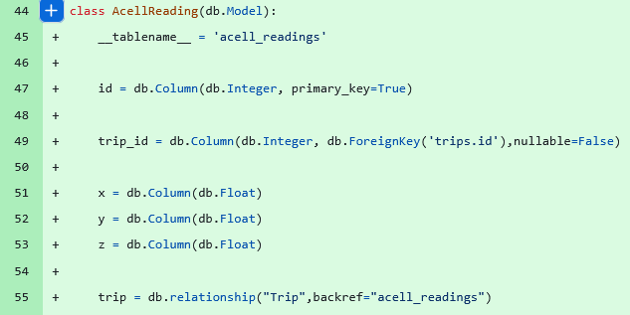  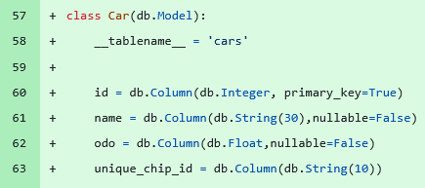  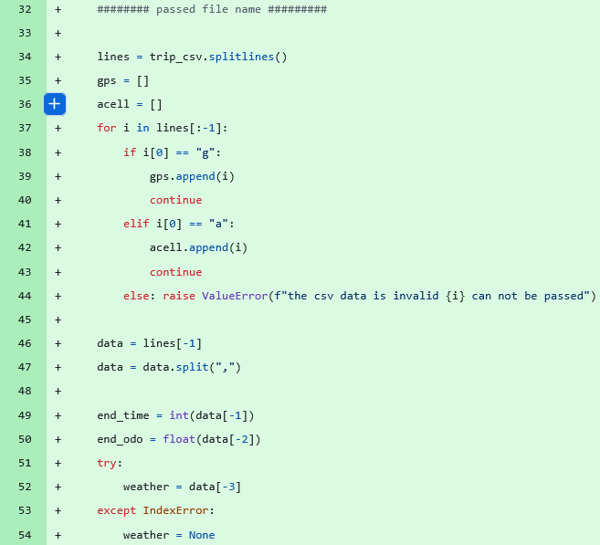  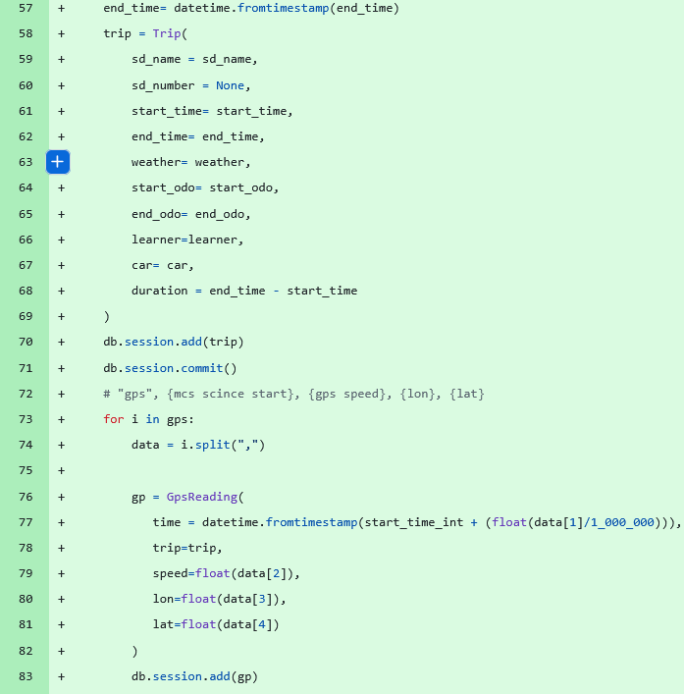  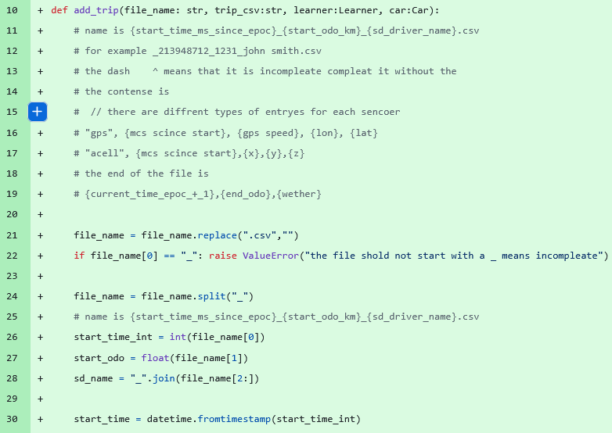  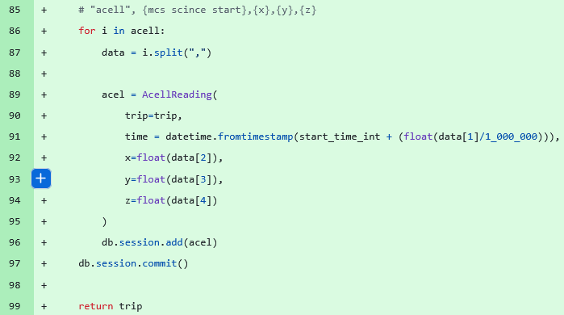
Logbook Entry: | Progress since the last entry:  I've started my a real proper PWA this is no longer just a little test at the time intending to work on for the rest of the project  I have started defining my database schema  made a parser for CSV files to database objects  Task Achieved:  define a database schema in SQL alchemy  I made a way of taking a CSV file and a learn object as well as a title of the file and a car that's all information that will be provided in a get request from the ESP when uploading the trip to be sent to the SQL database. This is not the clearest implementation of a passer but it is good enough and because it is a black box function I can always update it later if it is a bottleneck  Stumbling blocks or issues encountered and how they were managed:  semi colons they're crazy for the first 50 lines I kept on putting in semi colon's everywhere because I was writing in CPP before But then switching over to Python which does not need semi colons it was quite jarring also some of the syntax took a while I kept on trying to define strings with strings at the beginning. Also some of the iteration got a little bit complicated with the exact implementation of the Python methods because it had been a couple of weeks since I've used him and I had to Google to check the exact inputs for example these split lines and the split functions I thought then modified the data instead of returning it  Also converting from epoch time to a datetime object was a bit tricky  Possible approaches for upcoming tasks:  I need to define a user class that will be created when the user logs in I also need to do AI features and start writing some HTML and also do some diagrams to work out what I want the layout of this website to look like  Reflective comments:
Resources: | it was mostly the code that was existing on the Ed stamp and I just modified it for my needs as well as some for how to do foreign keys  https://www.geeksforgeeks.org/python/sqlalchemy-core-multiple-tables/

Date:
Title:
Author:
Tasks Description:
Image:
Logbook Entry: | Progress since the last entry:  Task Achieved:  Stumbling blocks or issues encountered and how they were managed:  Possible approaches for upcoming tasks:  Reflective comments:
Resources:

Date: | 2/2/2026
Title: | Work out how to integrate ai advanced future
Author: | Freddy Gaffey
Tasks Description: | Find ai platform that lets me have models with custom context and generate the context
Image: | 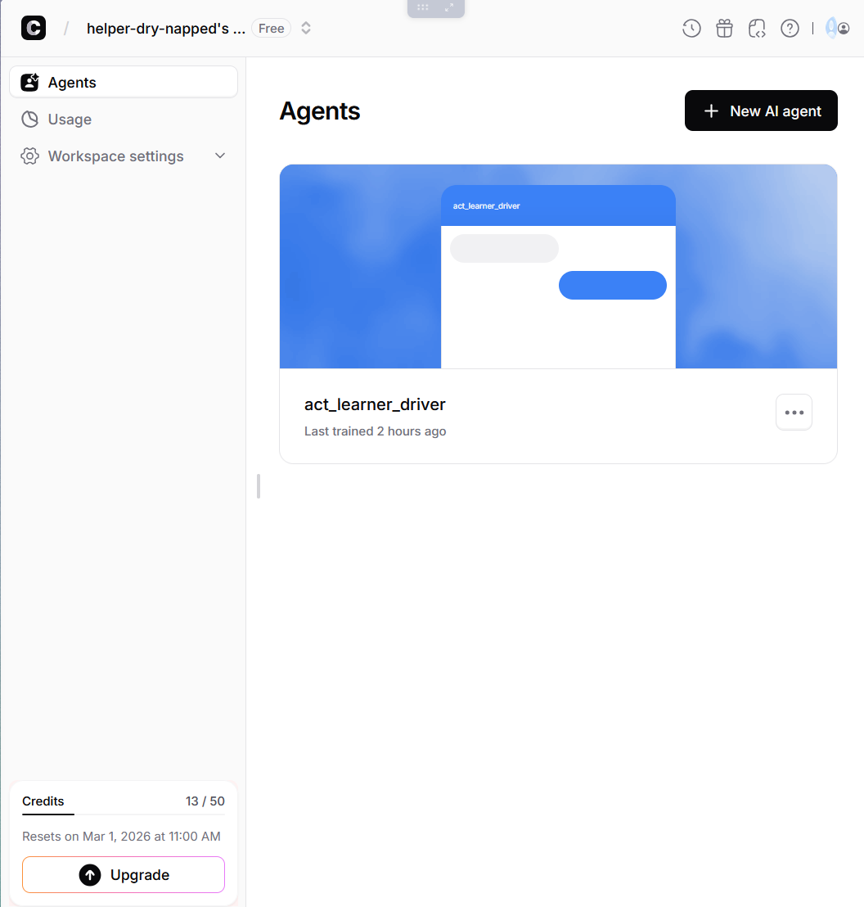  I also go to Claud to make a template for generating the rag document then I got it to make the actual RAG documents the prompts and the code the git repo as it is to long to put here
Logbook Entry: | Progress since the last entry:  Task Achieved:  Stumbling blocks or issues encountered and how they were managed:  Possible approaches for upcoming tasks:  Reflective comments:
Resources:

Date: | 3/2/2026
Title: | Work out how to bypass https to http again
Author: | Freddy Gaffey
Tasks Description: | Make a story board to help work out what the server should to and the esp 32
Image: | 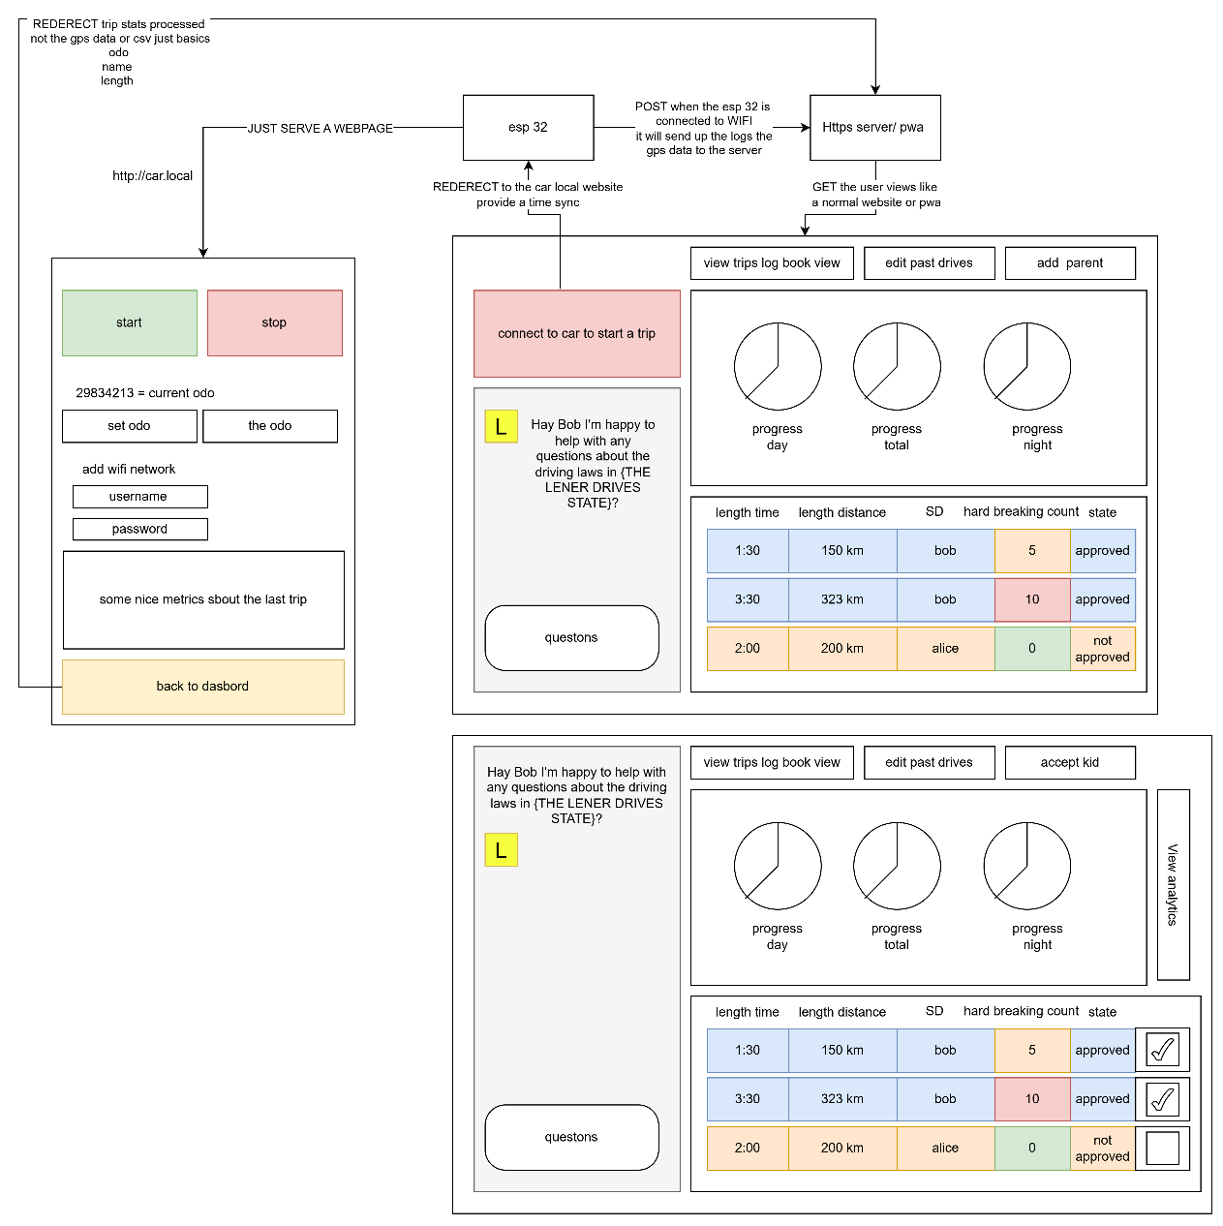
Logbook Entry: | Progress since the last entry:  I made the beginnings of a story bord and also I decided to have the drive controller to be on the hosted on the esp 32  Task Achieved:  Stumbling blocks or issues encountered and how they were managed:  It was fairly easy, I had already given this a great amount to thought  Possible approaches for upcoming tasks:  See above  Reflective comments:  YES I finally worked it out for real this time
Resources:

Date: | 21/2/2026
Title: | Change to Capacitor from PWA
Author: | Freddy Gaffey
Tasks Description: | Did research on native apps and decided to switch as Bluetooth has no support for PWAs on iso so I was doing a really janky approach with redirects and wifi but I will now use a Capacitor native runtime that is cross-platform.  Then after that I have meeting with my old IT teacher from Canberra grammar school we discussed. XXXXXXXXX put in the email XXXXXXXX  I made a vibe coded app to test out ui as a prototype I will use this to help me make ui improvements and also to as an example for when I make it my self this also lets me look at different architectures and evaluate the best one for me.
Image:
Logbook Entry: | Progress since the last entry:  Switched to capacitor  Vibe coded a prototype  Task Achieved:  Just research and design work no features completed  Stumbling blocks or issues encountered and how they were managed:  Not that much I stat down with my old IT teacher for 4 hours to work these things out  Possible approaches for upcoming tasks:  s  Reflective comments:
Resources:

Date:
Title: | Made a vibe coded app to evaluate architecture and UI
Author:
Tasks Description:
Image:
Logbook Entry: | Progress since the last entry:  Task Achieved:  Stumbling blocks or issues encountered and how they were managed:  Possible approaches for upcoming tasks:  Reflective comments:
Resources:

Date: | 23/2/26
Title: | Designed how to trip and dashboard work
Author: | Freddy Gaffey
Tasks Description: | Design the trip to work better
Image: | 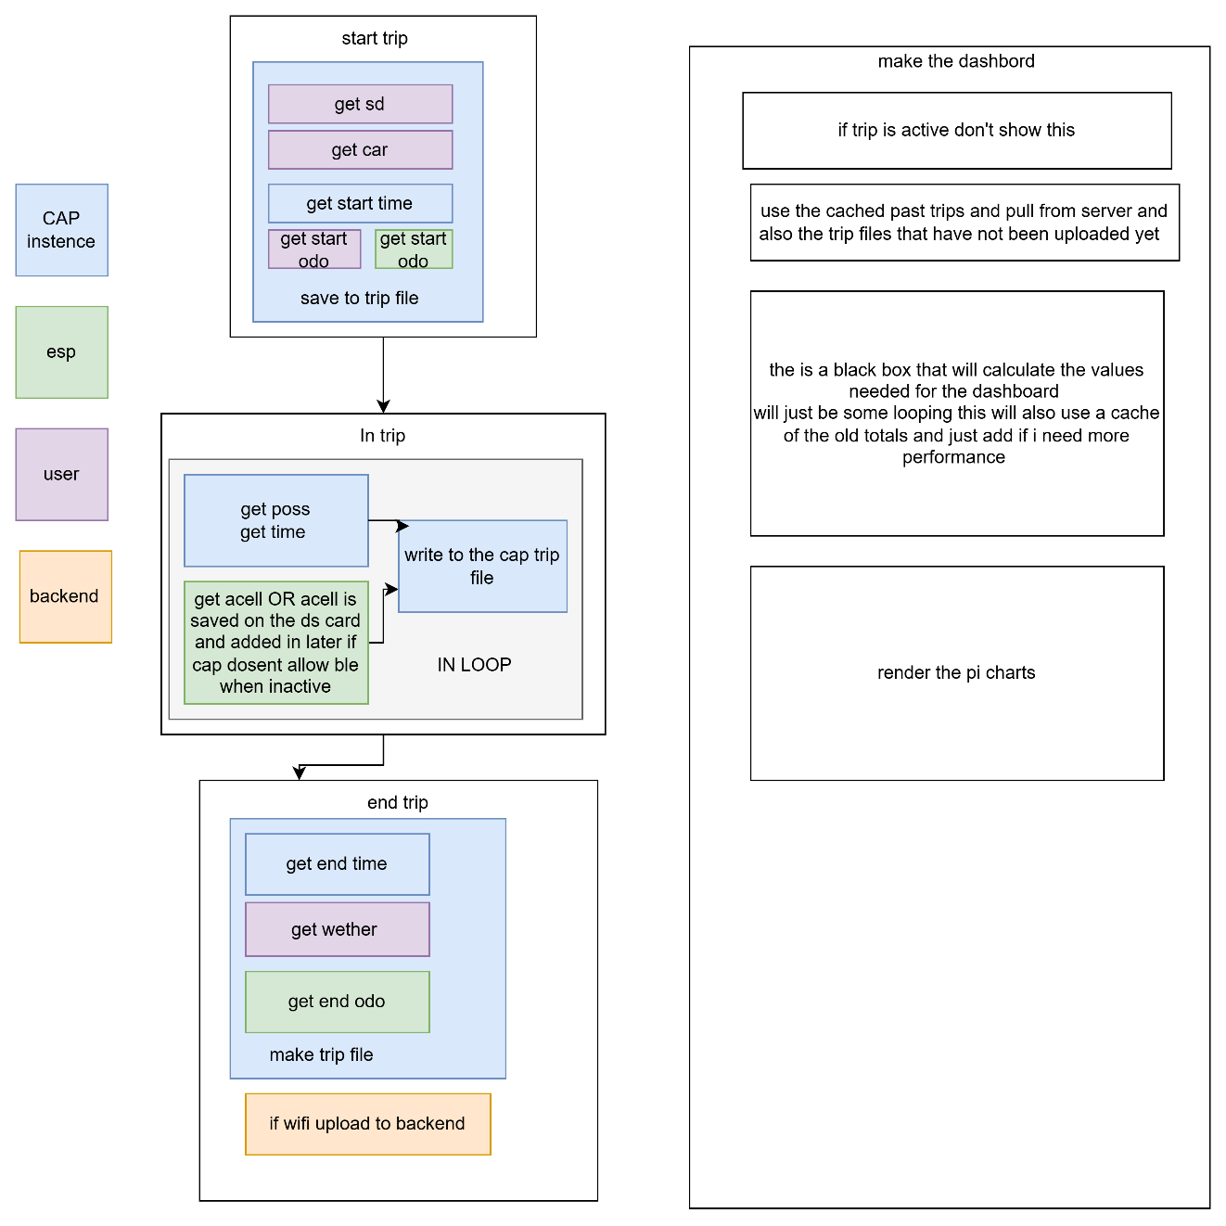
Logbook Entry: | Progress since the last entry:  Did some design work  Task Achieved:  Got a preliminary on the trip design  Stumbling blocks or issues encountered and how they were managed:  Nill  Possible approaches for upcoming tasks:  See above  Reflective comments:  I am felling confidant
Resources: | My brain

Date: | 28/2/2046
Title: | Made up prototypes with a ai agent
Author: | Freddy Gaffey
Tasks Description: | Made some UI prototypes to do market research  I used a ai Claude to make a app with all the fetures then I asked it to make me a prompt to generate mor app like that and to add the the propt to make the app different and through that prosses I got the following prompt that I used to make this app that you will see here  “””L-Plate Logger — UI Prototype Generator Prompt  You are designing a UI prototype for L-Plate Logger, an Australian learner driver hours tracking app. This is a UI prototype only — all data is mocked, there is no backend. The purpose is to explore innovative and visually distinct interface designs for market research, so each time this prompt is used, produce a completely different visual style, layout, colour scheme, typography, and interaction pattern. Be creative and experimental — try unconventional layouts, bold aesthetics, and novel interaction ideas. The goal is to generate a range of diverse prototypes that can be shown to potential users to gauge preferences.  Output a single self-contained HTML file with inline CSS and JavaScript. It must work on mobile (optimised for small screens) and desktop.  App Overview  An app that helps NSW learner drivers track their 120 required supervised driving hours (including 20 night hours) needed to obtain a P1 licence. The app logs trips, tracks progress, lets parents/supervisors approve trips, and includes an AI chatbot for road rules questions.  Required Features  Authentication  A login screen and a registration screen (or combined)  Registration collects: first name, last name, email, password, account type (Learner Driver or Parent/Supervisor), and Australian state  Password must be minimum 8 characters  Validate all fields and show error messages for invalid input  Include a demo/quick-login button for fast access  A mock user database with at least one pre-existing learner account and one parent account  Session persistence within the tab so refreshing stays logged in  Sign out functionality that returns to the login screen  Trip Logger  The primary screen of the app — this is what users see most  A start/stop trip recording control that is immediately accessible on mobile without scrolling — this is the most critical interaction  Before starting a trip, the user must select a vehicle and a supervising driver  The user can tag driving conditions before or during a trip (rain, night, city, highway, school zone, rural)  While a trip is recording, display live mock data: current speed, distance travelled, elapsed time, harsh braking count  Show mock phone GPS coordinates and accuracy during recording  Display overall progress toward the 120 hour requirement, broken down into day hours and night hours (20h night minimum)  Trip History  A scrollable list of past mock trips  Each trip shows: date, time, duration, distance, supervising driver, vehicle, conditions, and approval status (approved or pending)  Tapping a trip shows more detail  Ability to filter trips (by status, by night driving, etc.)  Visual charts (pie/donut) summarising trip data broken down by:  Day vs night hours  Driving conditions  Supervising driver  Vehicle  Approval status  Road Rules AI Chatbot  A chat interface where users can ask questions about NSW learner driving laws  Pre-populated suggested questions the user can tap  Mock AI responses for at least these topics: hours required for P1, night driving rules, speed limits for learners, logbook requirements  A default response for any other question  Show a typing/thinking indicator before responses appear  Support basic text formatting in responses (bold text)  Settings  Display the logged-in user's profile (avatar/initials, name, account type, state)  A working light/dark theme toggle that persists  Menu items for: Profile, Supervisors, Parent Access, Phone GPS, Location Accuracy, Logger Defaults, Export Logbook  All of these menu items show a message: "This feature has not been implemented as it is a demo"  Sign out button  General Requirements  Mobile-first responsive design that also works on desktop  Toast/snackbar notifications for user feedback on actions  Navigation between all sections of the app  All data is mocked with realistic Australian learner driver data  Light and dark mode support  Mock Data to Include  Users  A learner driver account (any name, email: demo@lplate.app, password: password123, state: NSW)  A parent/supervisor account (any name, email: parent@lplate.app, password: password123, state: NSW)  Trips (at least 7)  Include a mix of:  Day and night trips  Different supervisors (at least 2)  Different vehicles (at least 2)  Approved and pending statuses  Various conditions (highway, city, rain, night, rural, school zone)  Durations ranging from 30 minutes to 2+ hours  Realistic distances for the duration  Progress  Total hours logged should be roughly 50-70 hours out of 120  Night hours should be roughly 10-15 out of 20 required  Show this as a percentage and breakdown  AI Chatbot Responses  Provide accurate mock responses based on NSW road rules:  120 hours total required, 20 must be at night  Must hold learner licence for 12 months minimum  Maximum speed of 90 km/h regardless of posted limit  Must display L-plates front and rear  Zero blood alcohol concentration  Must be accompanied by a fully licensed driver at all times  Supervising driver must have held unrestricted licence for 1+ year  Log book must record: date, start/end times, duration, odometer readings, day/night, supervisor name and signature, road conditions  Important Notes  This is a UI prototype for market research — prioritise visual design and interaction quality  Try a completely different aesthetic direction each time — different colours, fonts, layouts, navigation patterns, animation styles  Explore innovative approaches: gesture-based interactions, card-based layouts, dashboard styles, map-centric views, gamification elements, minimalist designs, skeuomorphic designs, etc.  The start trip button must always be reachable without scrolling on a small mobile screen  Do not use the name "Fred" anywhere in the app  All settings features (except theme toggle and sign out) should show the demo not-implemented message”””  So I ran this 5 times and got the following apps  I also make a new repo as my old one was to terrible so disorganized like 100 branches nothing committed to main gitignore was never set up properly and I have to basically restart anyway now  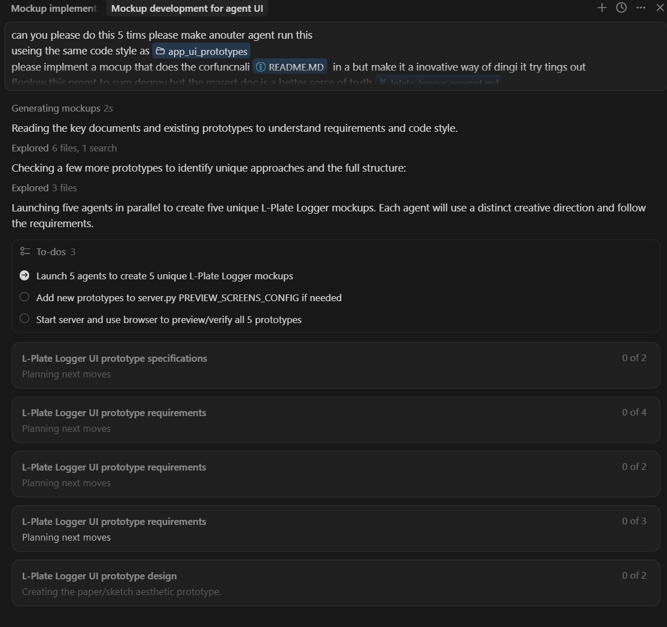  Look I know how to use agents
Image: | 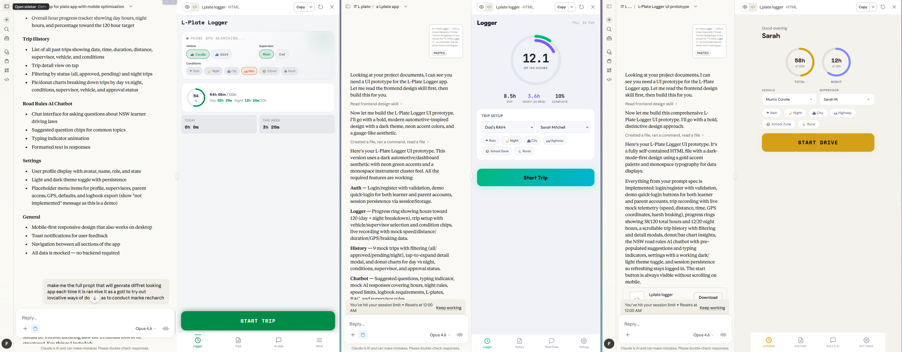  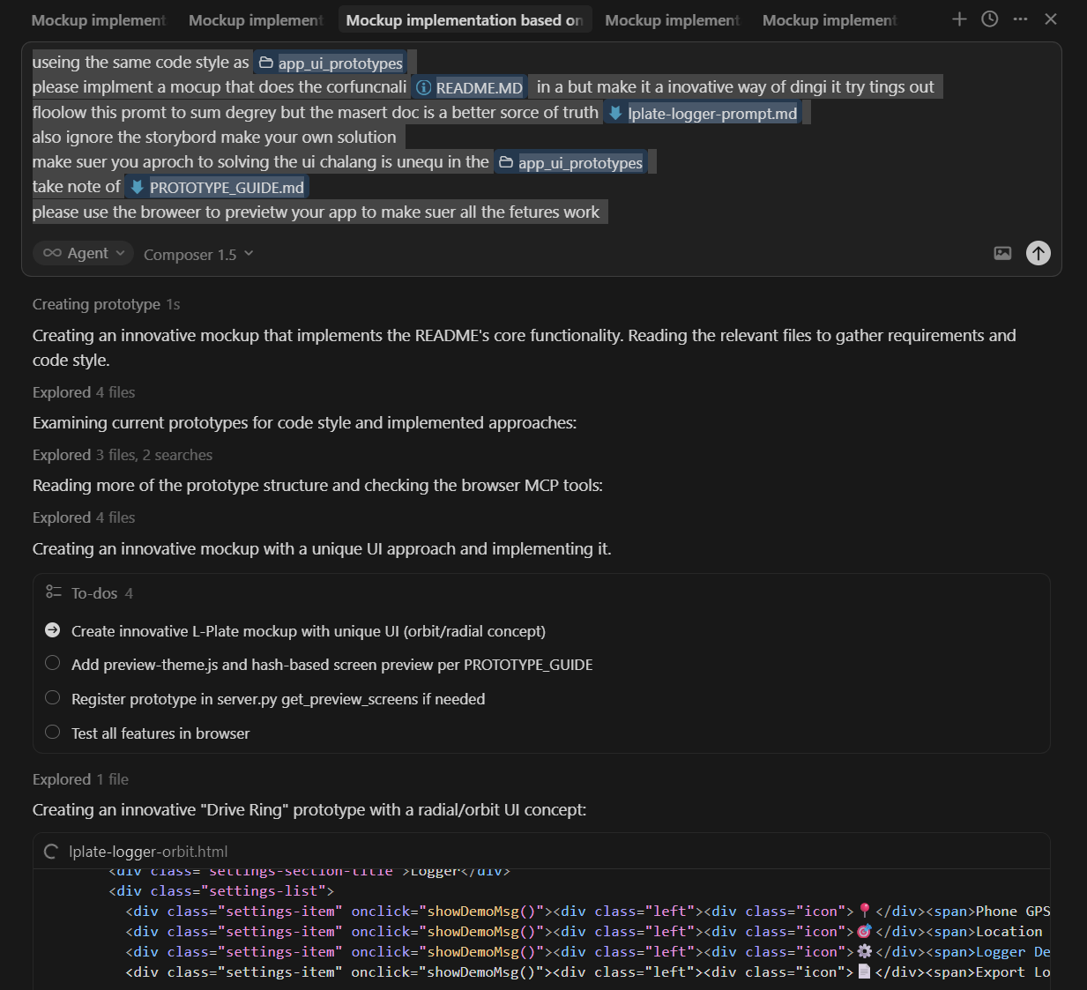  I also made a server to preview the application so that I user can use view them all  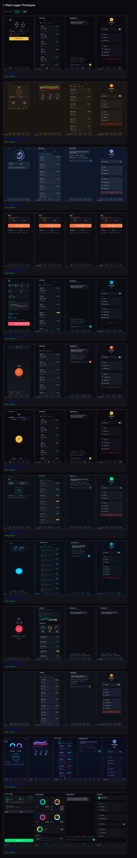
Logbook Entry: | Progress since the last entry:  Task Achieved:  Stumbling blocks or issues encountered and how they were managed:  Possible approaches for upcoming tasks:  Reflective comments:
Resources:

Date:
Title:
Author:
Tasks Description:
Image:
Logbook Entry: | Progress since the last entry:  Task Achieved:  Stumbling blocks or issues encountered and how they were managed:  Possible approaches for upcoming tasks:  Reflective comments:
Resources:

Date:
Title:
Author:
Tasks Description:
Image:
Logbook Entry: | Progress since the last entry:  Task Achieved:  Stumbling blocks or issues encountered and how they were managed:  Possible approaches for upcoming tasks:  Reflective comments:
Resources:

Date:
Title:
Author:
Tasks Description:
Image:
Logbook Entry: | Progress since the last entry:  Task Achieved:  Stumbling blocks or issues encountered and how they were managed:  Possible approaches for upcoming tasks:  Reflective comments:
Resources:

Date:
Title:
Author:
Tasks Description:
Image:
Logbook Entry: | Progress since the last entry:  Task Achieved:  Stumbling blocks or issues encountered and how they were managed:  Possible approaches for upcoming tasks:  Reflective comments:
Resources:

Date:
Title:
Author:
Tasks Description:
Image:

Date:
Title:
Author:
Tasks Description:
Image:
Logbook Entry: | Progress since the last entry:  Task Achieved:  Stumbling blocks or issues encountered and how they were managed:  Possible approaches for upcoming tasks:  Reflective comments:
Resources:

Date:
Title:
Author:
Tasks Description:
Image:
Logbook Entry: | Progress since the last entry:  Task Achieved:  Stumbling blocks or issues encountered and how they were managed:  Possible approaches for upcoming tasks:  Reflective comments:
Resources:

Date:
Title:
Author:
Tasks Description:
Image:
Logbook Entry: | Progress since the last entry:  Task Achieved:  Stumbling blocks or issues encountered and how they were managed:  Possible approaches for upcoming tasks:  Reflective comments:
Resources:

Date:
Title:
Author:
Tasks Description:
Image:
Logbook Entry: | Progress since the last entry:  Task Achieved:  Stumbling blocks or issues encountered and how they were managed:  Possible approaches for upcoming tasks:  Reflective comments:
Resources:

Date:
Title:
Author:
Tasks Description:
Image:
Logbook Entry: | Progress since the last entry:  Task Achieved:  Stumbling blocks or issues encountered and how they were managed:  Possible approaches for upcoming tasks:  Reflective comments:
Resources:

Date:
Title:
Author:
Tasks Description:
Image:
Logbook Entry: | Progress since the last entry:  Task Achieved:  Stumbling blocks or issues encountered and how they were managed:  Possible approaches for upcoming tasks:  Reflective comments:
Resources:

Date:
Title:
Author:
Tasks Description:
Image:
Logbook Entry: | Progress since the last entry:  Task Achieved:  Stumbling blocks or issues encountered and how they were managed:  Possible approaches for upcoming tasks:  Reflective comments:
Resources:

Date:
Title:
Author:
Tasks Description:
Image:
Logbook Entry: | Progress since the last entry:  Task Achieved:  Stumbling blocks or issues encountered and how they were managed:  Possible approaches for upcoming tasks:  Reflective comments:
Resources:

Date:
Title:
Author:
Tasks Description:
Image:
Logbook Entry: | Progress since the last entry:  Task Achieved:  Stumbling blocks or issues encountered and how they were managed:  Possible approaches for upcoming tasks:  Reflective comments:
Resources:

Date:
Title:
Author:
Tasks Description:
Image:
Logbook Entry: | Progress since the last entry:  Task Achieved:  Stumbling blocks or issues encountered and how they were managed:  Possible approaches for upcoming tasks:  Reflective comments:
Resources:

Date:
Title:
Author:
Tasks Description:
Image:
Logbook Entry: | Progress since the last entry:  Task Achieved:  Stumbling blocks or issues encountered and how they were managed:  Possible approaches for upcoming tasks:  Reflective comments:
Resources:

Date:
Title:
Author:
Tasks Description:
Image:
Logbook Entry: | Progress since the last entry:  Task Achieved:  Stumbling blocks or issues encountered and how they were managed:  Possible approaches for upcoming tasks:  Reflective comments:
Resources:

Date:
Title:
Author:
Tasks Description:
Image:
Logbook Entry: | Progress since the last entry:  Task Achieved:  Stumbling blocks or issues encountered and how they were managed:  Possible approaches for upcoming tasks:  Reflective comments:
Resources:

Logbook Entry: | Progress since the last entry:  Task Achieved:  Stumbling blocks or issues encountered and how they were managed:  Possible approaches for upcoming tasks:  Reflective comments:
Resources:

Date:
Title:
Author:
Tasks Description:
Image:
Logbook Entry: | Progress since the last entry:  Task Achieved:  Stumbling blocks or issues encountered and how they were managed:  Possible approaches for upcoming tasks:  Reflective comments:
Resources:

Date:
Title:
Author:
Tasks Description:
Image:
Logbook Entry: | Progress since the last entry:  Task Achieved:  Stumbling blocks or issues encountered and how they were managed:  Possible approaches for upcoming tasks:  Reflective comments:
Resources:

Date:
Title:
Author:
Tasks Description:
Image:
Logbook Entry: | Progress since the last entry:  Task Achieved:  Stumbling blocks or issues encountered and how they were managed:  Possible approaches for upcoming tasks:  Reflective comments:
Resources:

Date:
Title:
Author:
Tasks Description:
Image:
Logbook Entry: | Progress since the last entry:  Task Achieved:  Stumbling blocks or issues encountered and how they were managed:  Possible approaches for upcoming tasks:  Reflective comments:
Resources:

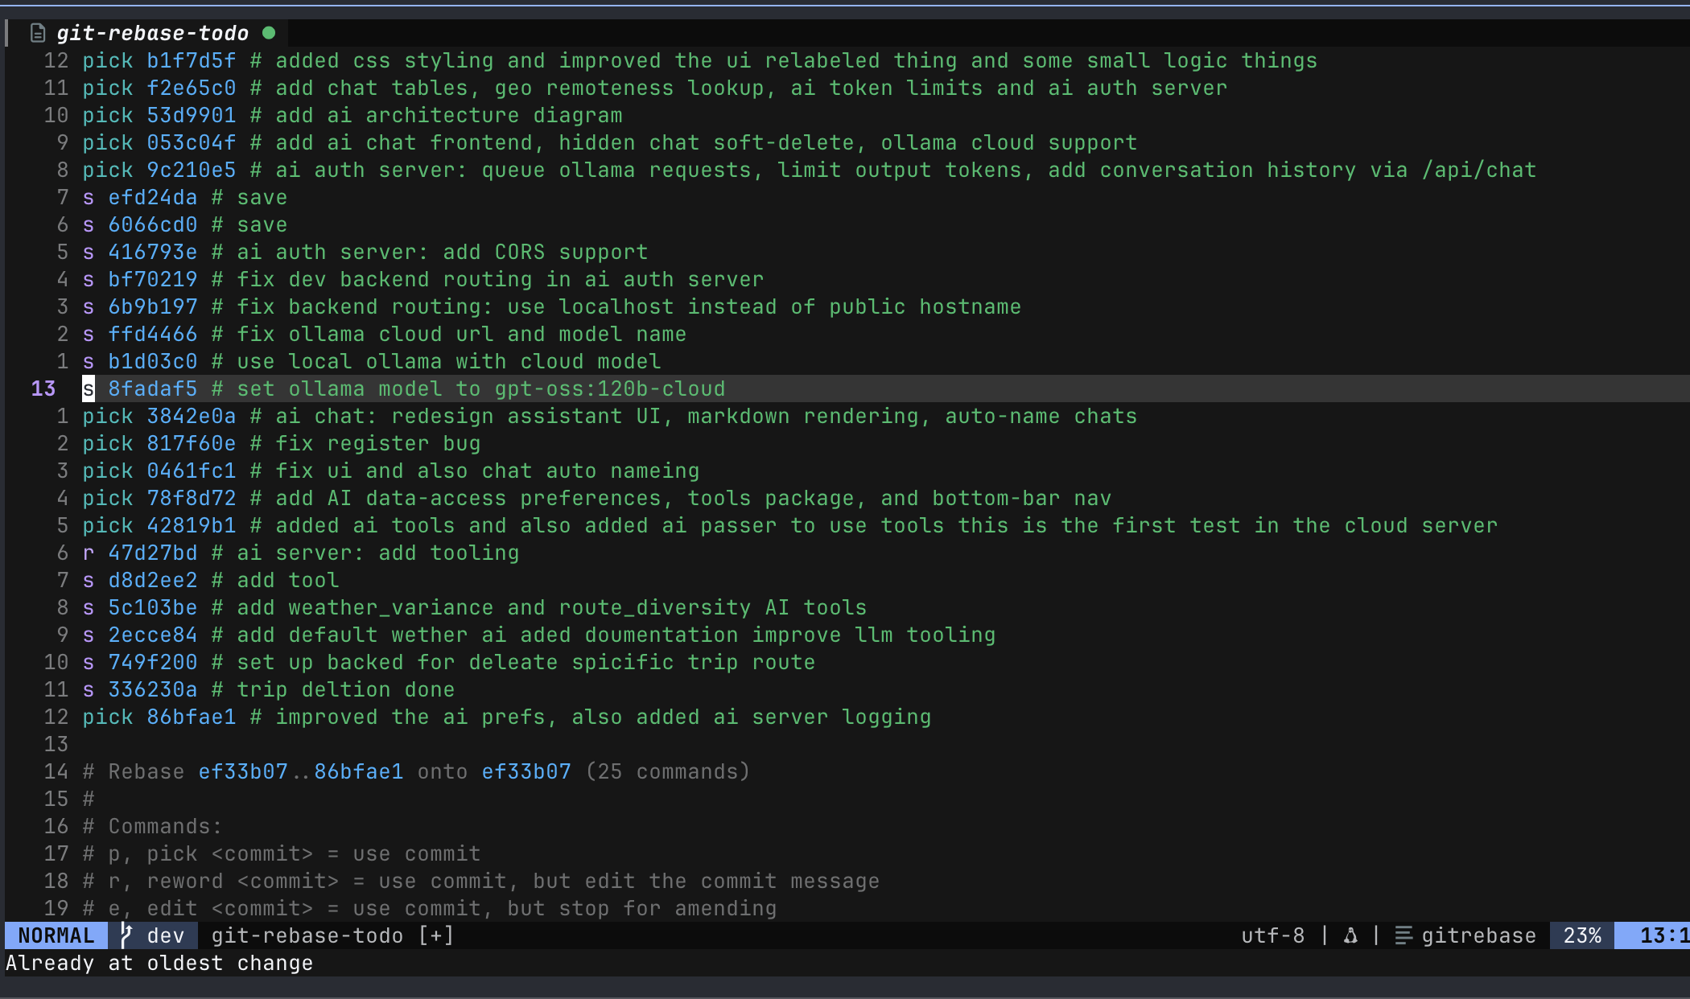
This is me rebase my commits it is relevant somewhere

I’m doing some security hardening now for the software because I’m considering selling this to the government so I needed to actually be secure not just secure enough for a software engineering assmegnt
I first run
npm audit
_----------------------------------------------------------------------------------------------------------------------------------
red@freds-mac all_code % npm audit
# npm audit report
@tootallnate/once <2.0.1
@tootallnate/once vulnerable to Incorrect Control Flow Scoping - https://github.com/advisories/GHSA-vpq2-c234-7xj6
fix available via `npm audit fix`
node_modules/@tootallnate/once

@xmldom/xmldom <=0.8.12
Severity: high
xmldom: Uncontrolled recursion in XML serialization leads to DoS - https://github.com/advisories/GHSA-2v35-w6hq-6mfw
xmldom has XML injection through unvalidated DocumentType serialization - https://github.com/advisories/GHSA-f6ww-3ggp-fr8h
xmldom has XML node injection through unvalidated processing instruction serialization - https://github.com/advisories/GHSA-x6wf-f3px-wcqx
xmldom has XML node injection through unvalidated comment serialization - https://github.com/advisories/GHSA-j759-j44w-7fr8
fix available via `npm audit fix`
node_modules/@xmldom/xmldom

brace-expansion 5.0.2 - 5.0.5
Severity: moderate
brace-expansion: Large numeric range defeats documented `max` DoS protection - https://github.com/advisories/GHSA-jxxr-4gwj-5jf2
fix available via `npm audit fix`
node_modules/rimraf/node_modules/brace-expansion

esbuild <=0.24.2
Severity: moderate
esbuild enables any website to send any requests to the development server and read the response - https://github.com/advisories/GHSA-67mh-4wv8-2f99
fix available via `npm audit fix --force`
Will install vite@8.1.4, which is a breaking change
node_modules/esbuild
vite <=6.4.2
Depends on vulnerable versions of esbuild
node_modules/vite
@vitejs/plugin-vue 1.8.0 - 5.2.0
Depends on vulnerable versions of vite
node_modules/@vitejs/plugin-vue
vite-node <=2.2.0-beta.2
Depends on vulnerable versions of vite
node_modules/vite-node
vitest <=3.2.5
Depends on vulnerable versions of vite
Depends on vulnerable versions of vite-node
node_modules/vitest

form-data 4.0.0 - 4.0.5
Severity: high
form-data: CRLF injection in form-data via unescaped multipart field names and filenames - https://github.com/advisories/GHSA-hmw2-7cc7-3qxx
fix available via `npm audit fix`
node_modules/form-data

js-cookie <=3.0.5
Severity: high
JavaScript Cookie: Per-instance prototype hijack in assign() enables cookie-attribute injection - https://github.com/advisories/GHSA-qjx8-664m-686j
fix available via `npm audit fix`
node_modules/js-cookie

js-yaml 4.0.0 - 4.1.1
Severity: moderate
JS-YAML: Quadratic-complexity DoS in merge key handling via repeated aliases - https://github.com/advisories/GHSA-h67p-54hq-rp68
fix available via `npm audit fix`
node_modules/js-yaml

minimatch 9.0.0 - 9.0.6
Severity: high
minimatch has a ReDoS via repeated wildcards with non-matching literal in pattern - https://github.com/advisories/GHSA-3ppc-4f35-3m26
minimatch has ReDoS: matchOne() combinatorial backtracking via multiple non-adjacent GLOBSTAR segments - https://github.com/advisories/GHSA-7r86-cg39-jmmj
minimatch ReDoS: nested *() extglobs generate catastrophically backtracking regular expressions - https://github.com/advisories/GHSA-23c5-xmqv-rm74
fix available via `npm audit fix`
node_modules/minimatch
@typescript-eslint/typescript-estree 6.16.0 - 7.5.0
Depends on vulnerable versions of minimatch
node_modules/@typescript-eslint/typescript-estree
@typescript-eslint/parser 6.16.0 - 7.5.0
Depends on vulnerable versions of @typescript-eslint/typescript-estree
node_modules/@typescript-eslint/parser
@typescript-eslint/type-utils 6.16.0 - 7.5.0
Depends on vulnerable versions of @typescript-eslint/typescript-estree
Depends on vulnerable versions of @typescript-eslint/utils
node_modules/@typescript-eslint/type-utils
@typescript-eslint/utils 6.16.0 - 7.5.0
Depends on vulnerable versions of @typescript-eslint/typescript-estree
node_modules/@typescript-eslint/utils
@typescript-eslint/eslint-plugin 6.16.0 - 7.5.0
Depends on vulnerable versions of @typescript-eslint/type-utils
Depends on vulnerable versions of @typescript-eslint/utils
node_modules/@typescript-eslint/eslint-plugin

postcss <8.5.10
Severity: moderate
PostCSS has XSS via Unescaped </style> in its CSS Stringify Output - https://github.com/advisories/GHSA-qx2v-qp2m-jg93
fix available via `npm audit fix`
node_modules/postcss

qs 6.11.1 - 6.15.1
Severity: moderate
qs has a remotely triggerable DoS: qs.stringify crashes with TypeError on null/undefined entries in comma-format arrays when encodeValuesOnly is set - https://github.com/advisories/GHSA-q8mj-m7cp-5q26
fix available via `npm audit fix`
node_modules/qs
@cypress/request <=4.0.0
Depends on vulnerable versions of qs
Depends on vulnerable versions of uuid
node_modules/@cypress/request
cypress 13.15.0 - 15.14.2
Depends on vulnerable versions of @cypress/request
node_modules/cypress

tar <=7.5.15
Severity: moderate
node-tar applies PAX size override to intermediary GNU long-name/long-link headers, causing tar parser interpretation differential (file smuggling) - https://github.com/advisories/GHSA-vmf3-w455-68vh
fix available via `npm audit fix`
node_modules/tar

tmp <0.2.6
Severity: high
tmp has Path Traversal via unsanitized prefix/postfix that enables directory escape - https://github.com/advisories/GHSA-ph9p-34f9-6g65
fix available via `npm audit fix`
node_modules/tmp

uuid <11.1.1
Severity: moderate
uuid: Missing buffer bounds check in v3/v5/v6 when buf is provided - https://github.com/advisories/GHSA-w5hq-g745-h8pq
fix available via `npm audit fix`
node_modules/uuid

ws 8.0.0 - 8.20.1
Severity: high
ws: Uninitialized memory disclosure - https://github.com/advisories/GHSA-58qx-3vcg-4xpx
ws: Memory exhaustion DoS from tiny fragments and data chunks - https://github.com/advisories/GHSA-96hv-2xvq-fx4p
fix available via `npm audit fix`
node_modules/ws

25 vulnerabilities (1 low, 11 moderate, 12 high, 1 critical)

To address issues that do not require attention, run:
npm audit fix

To address all issues (including breaking changes), run:
npm audit fix --force
fred@freds-mac all_code % npm audit fix

changed 12 packages, and audited 543 packages in 30s

115 packages are looking for funding
run `npm fund` for details

# npm audit report

esbuild <=0.24.2
Severity: moderate
esbuild enables any website to send any requests to the development server and read the response - https://github.com/advisories/GHSA-67mh-4wv8-2f99
fix available via `npm audit fix --force`
Will install vite@8.1.4, which is a breaking change
node_modules/esbuild
vite <=6.4.2
Depends on vulnerable versions of esbuild
node_modules/vite
@vitejs/plugin-vue 1.8.0 - 5.2.0
Depends on vulnerable versions of vite
node_modules/@vitejs/plugin-vue
vite-node <=2.2.0-beta.2
Depends on vulnerable versions of vite
node_modules/vite-node
vitest <=3.2.5
Depends on vulnerable versions of vite
Depends on vulnerable versions of vite-node
node_modules/vitest

minimatch 9.0.0 - 9.0.6
Severity: high
minimatch has a ReDoS via repeated wildcards with non-matching literal in pattern - https://github.com/advisories/GHSA-3ppc-4f35-3m26
minimatch has ReDoS: matchOne() combinatorial backtracking via multiple non-adjacent GLOBSTAR segments - https://github.com/advisories/GHSA-7r86-cg39-jmmj
minimatch ReDoS: nested *() extglobs generate catastrophically backtracking regular expressions - https://github.com/advisories/GHSA-23c5-xmqv-rm74
fix available via `npm audit fix`
node_modules/minimatch
@typescript-eslint/typescript-estree 6.16.0 - 7.5.0
Depends on vulnerable versions of minimatch
node_modules/@typescript-eslint/typescript-estree
@typescript-eslint/parser 6.16.0 - 7.5.0
Depends on vulnerable versions of @typescript-eslint/typescript-estree
node_modules/@typescript-eslint/parser
@typescript-eslint/type-utils 6.16.0 - 7.5.0
Depends on vulnerable versions of @typescript-eslint/typescript-estree
Depends on vulnerable versions of @typescript-eslint/utils
node_modules/@typescript-eslint/type-utils
@typescript-eslint/eslint-plugin 6.16.0 - 7.5.0
Depends on vulnerable versions of @typescript-eslint/type-utils
Depends on vulnerable versions of @typescript-eslint/utils
node_modules/@typescript-eslint/eslint-plugin
@typescript-eslint/utils 6.16.0 - 7.5.0
Depends on vulnerable versions of @typescript-eslint/typescript-estree
node_modules/@typescript-eslint/utils

qs 6.11.1 - 6.15.1
Severity: moderate
qs has a remotely triggerable DoS: qs.stringify crashes with TypeError on null/undefined entries in comma-format arrays when encodeValuesOnly is set - https://github.com/advisories/GHSA-q8mj-m7cp-5q26
fix available via `npm audit fix`
node_modules/qs
@cypress/request <=4.0.0
Depends on vulnerable versions of qs
Depends on vulnerable versions of uuid
node_modules/@cypress/request
cypress 13.15.0 - 15.14.2
Depends on vulnerable versions of @cypress/request
node_modules/cypress

uuid <11.1.1
Severity: moderate
uuid: Missing buffer bounds check in v3/v5/v6 when buf is provided - https://github.com/advisories/GHSA-w5hq-g745-h8pq
fix available via `npm audit fix`
node_modules/uuid

15 vulnerabilities (7 moderate, 7 high, 1 critical)

To address issues that do not require attention, run:
npm audit fix

To address all issues (including breaking changes), run:
npm audit fix --force
fred@freds-mac all_code %
_-----------------------------------------------------------------------------------------------------------
I got “25 vulnerabilities (1 low, 11 moderate, 12 high, 1 critical)”
So I ran npm audit fix that got me down to
15 vulnerabilities (7 moderate, 7 high, 1 critical)
Then I ran npm audit –
force10 vulnerabilities (4 moderate, 6 high)

not I have 10 vulnerabilities left to fix so I’m going to get Claude to apply the rest of the fixes to my dependencies
Now I've done that I am going to get fable 5 to put together a comprehensive list of vulnerability testing tools to run over to my project and I'm just going to run them all over it and hopefully it's going to catch some things
after that I'm going to protect my server with SSH and no port forwarding with SH and only being able to access it through local network through tail scale so congure

claude was Successfully ran and fixed all my vulnerabilities and just applied the patches by unpinning some versions and stuff this is not stuff that I need to worry myself about because NPM should protect me.

SADLY FABLE 5 WAS BEING A ANNOYING and it wouldn’t let me talk about cyber security things with it but we have opus 4.6
I will now need to do some more hand holding but I will maks sure I do tesing for
STAT and DAST as well a SEQUL injection also ssh protecting
This is what I gave me
1. gitleaks + trufflehog (minutes, immediate findings)
2. Semgrep + Bandit + pip-audit + npm audit (one afternoon, local, no infra needed)
3. Turn on Dependabot + CodeQL on GitHub (set-and-forget)
4. ZAP authenticated + testssl.sh against dev.lflip.pebnum.com (needs the VPS up)
5. MobSF on a release build
they all sound great and some of them are better than what I could have thought of
I have now Turned on all my security features that could help in GitHub

I set up a bot that will automatically keep my dendency in order by making a PR when needed
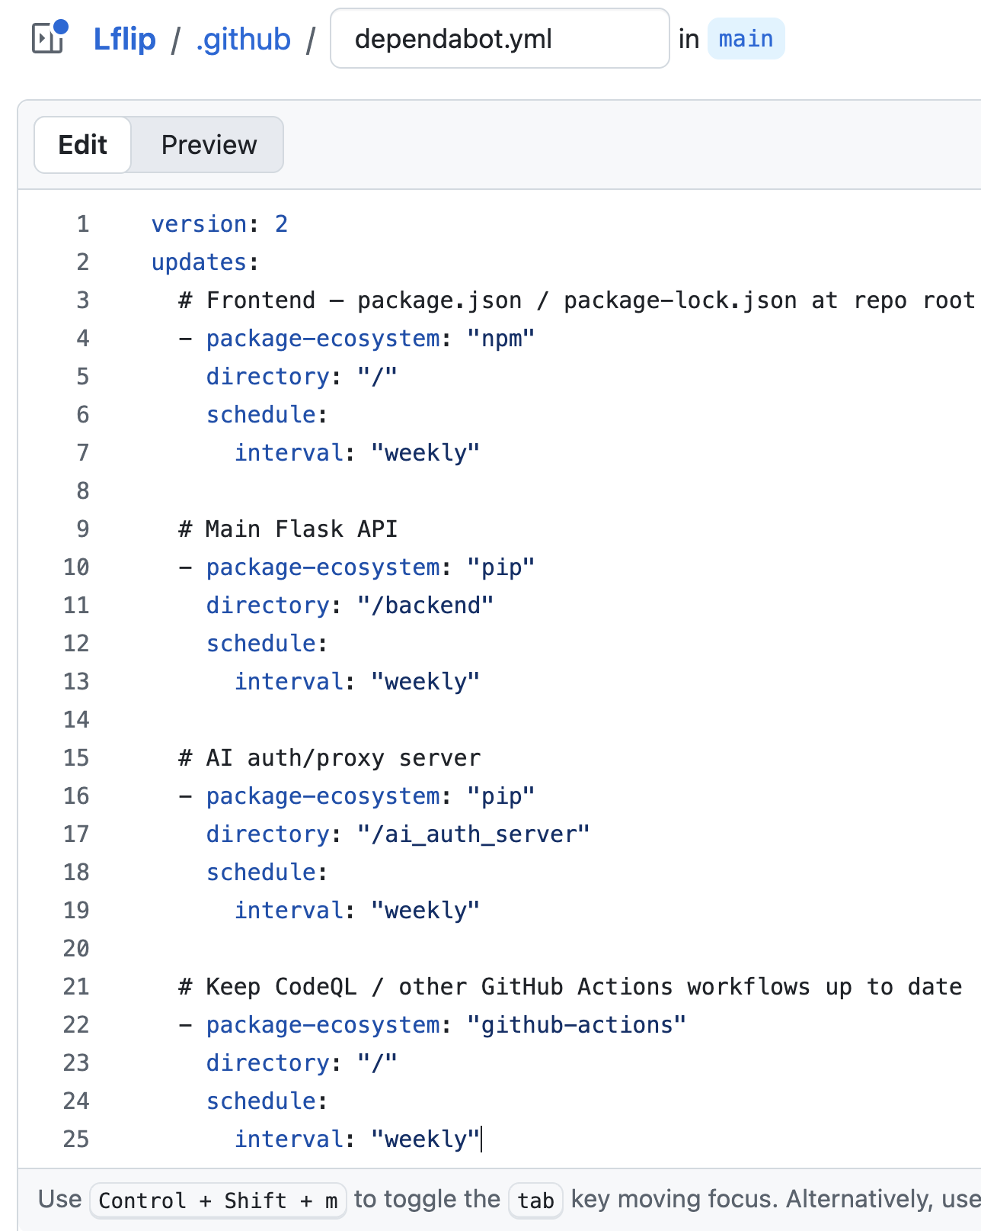
It found things
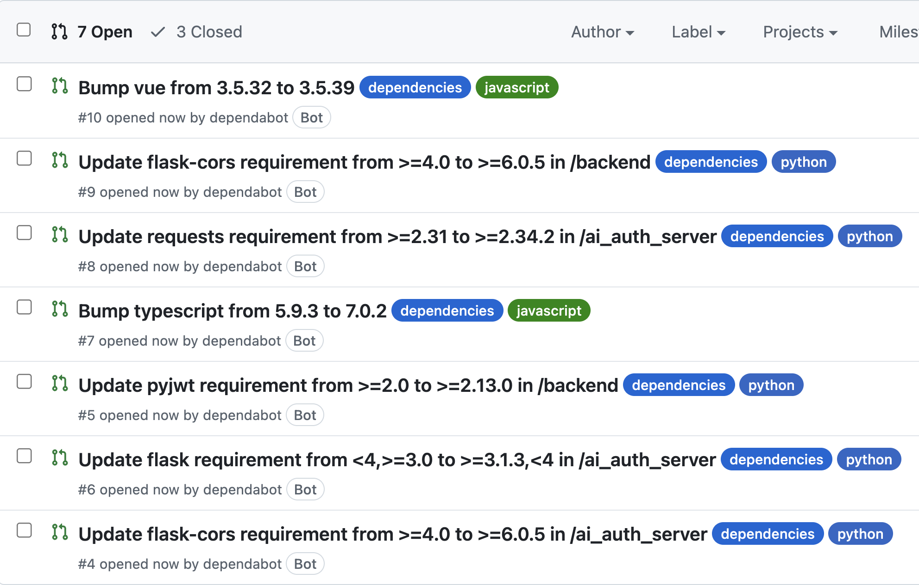
This is great now I cant get hacked!!!!!! Not really but this is still great
But I also found I had commited my keys to github this is ok as it was a privit repo but git hub has been hack so much reasetly that I should not trust it.
There were more scan run 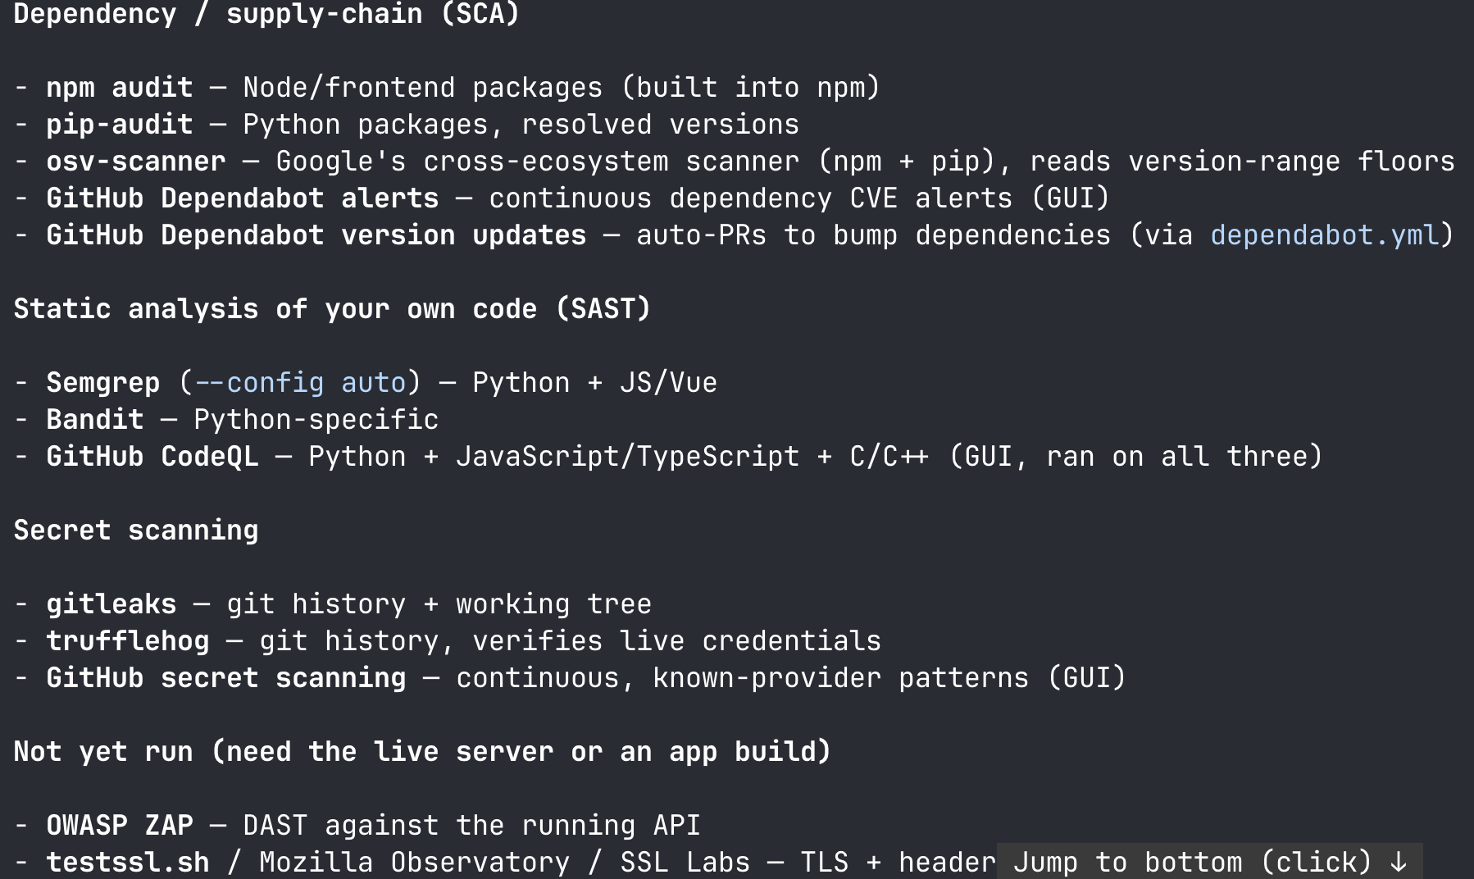
I also have cloud flare chekcig if I will break there build as I am deplying the forunt end with cloudflar pages
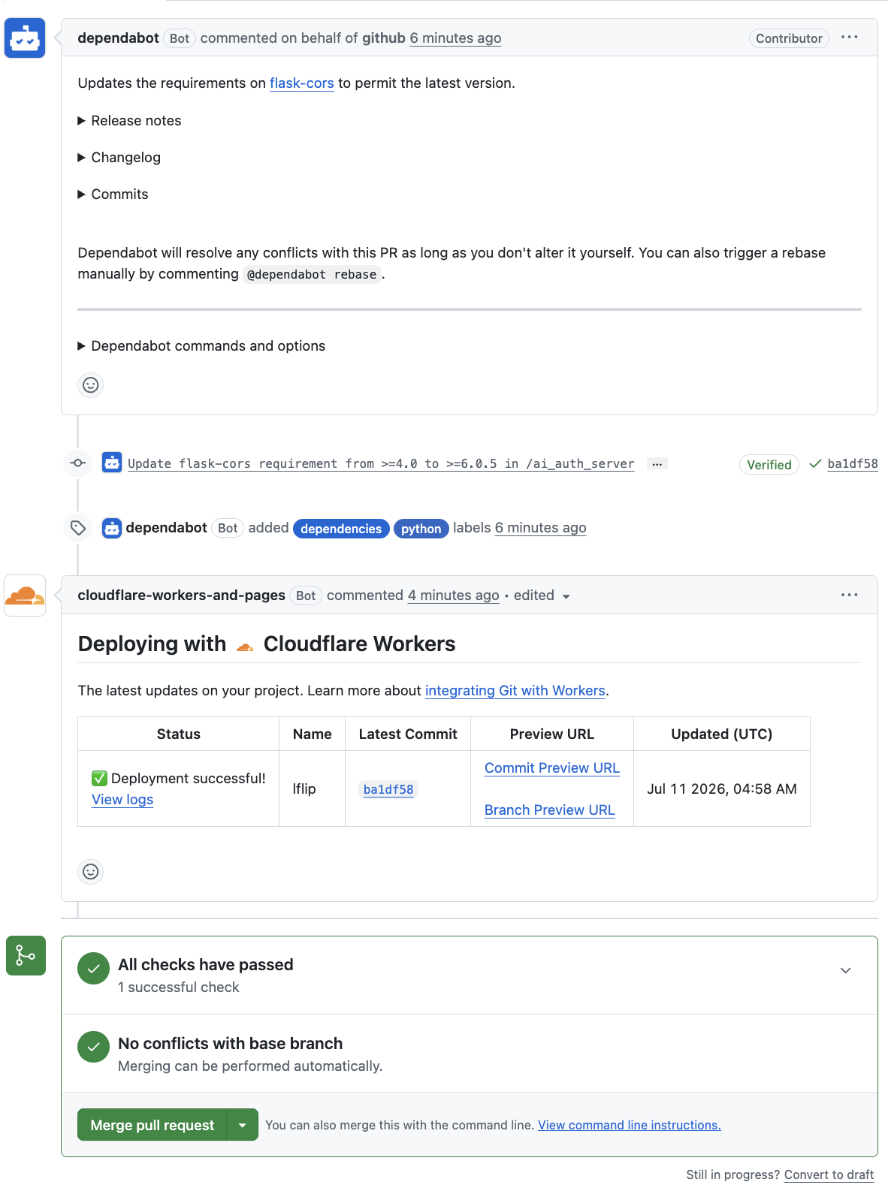
I will address all these issue once I merge my dev branch in to main

I edit the systemclt to make them use the right env file with
EnvironmentFile=/home/fred/Lflip/backend/.env.{dev,prod}
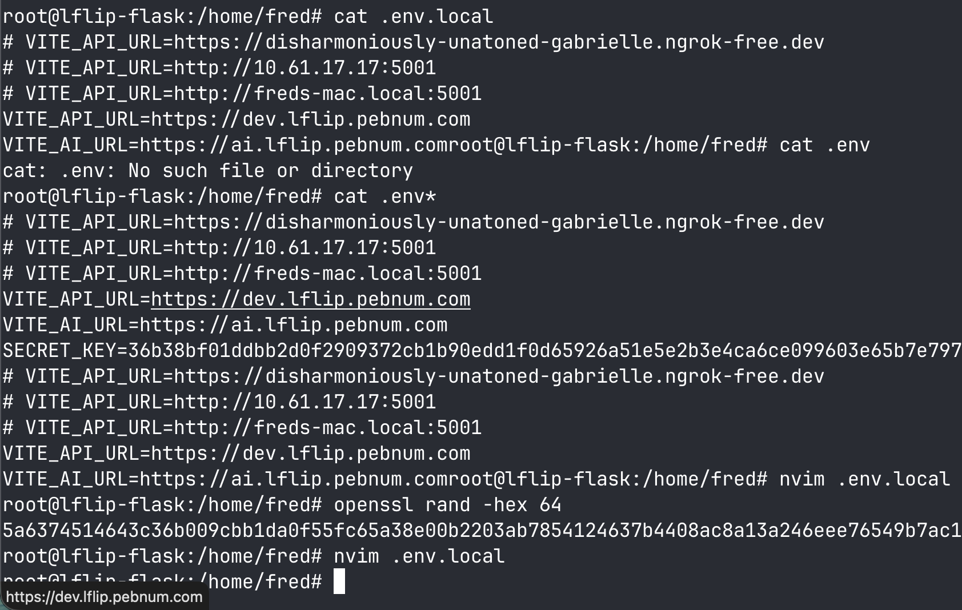
NOTE:cropped the keys
Restarted the systemclt
root@lflip-flask:/home/fred# ./restart_all.sh
Warning: The unit file, source configuration file or drop-ins of lflip.service changed on disk. Run 'systemctl daemon-reload' to reload units.
Warning: The unit file, source configuration file or drop-ins of dev-lflip.service changed on disk. Run 'systemctl daemon-reload' to reload units.
root@lflip-flask:/home/fred# systemctl daemon-reload
root@lflip-flask:/home/fred#
I then ran som script to pull and now I am using the new keys
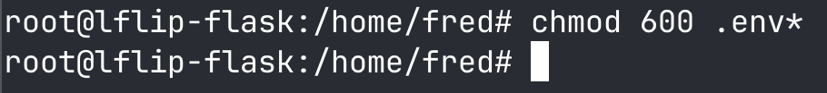

Now claude using the scanner not full dast and stat but just linters found some vurbiltys so I fixed most of them.
I have also implemented cookies finally!!!!!!!!! Now everything is not in local storage so now things are safer I will talk about this later. But this is not a issue because I would never wright bad code !!!!!
I got all the low hanging fruit with the following commits the commit messages speek for them slefs but if you need more email the author(me).
fred@freds-mac all_code % git log --graph --date=short --pretty=format:'%h %ad %s' -10
* bc4c537 2026-07-11 Route cars store through the API helper
* b371476 2026-07-11 Route views through the API helper for cookie/Bearer auth
* d3394dc 2026-07-11 Route auth data stores through the API helper (svs, chats, aiPrefs)
* 9d8ab15 2026-07-11 Add API helper so auth works on web (cookie) and mobile (Bearer)
* ad19936 2026-07-11 Secure the auth cookie for HTTPS cookie-based auth
* 234fb69 2026-07-11 remove a remote code execution from a the dev server having debug=True
* 49ed492 2026-07-11 remove plain text loging of passwordsgit add backend/app.py
* 35f48cd 2026-07-11 remove the key the file add put it in a env file
* 9b4c54d 2026-07-11 Bump vue from 3.5.32 to 3.5.39
* 61d7e2a 2026-07-11 Configure Dependabot for multiple package ecosystems
fred@freds-mac all_code %

What I essentially did was I started by cleaning up maybe i's cleaning up some DMV files you saw this above I think then I did some fixing up some leftovers from debugging servers etc and then finally I cleared up the API and I made a API class which allowed me to simplify my code dramatically while allowing for different functionality on different operating systems so for iOS it worked by not using cookies but using JavaScript web token bearer tokens and this is beneficial because it iOS is protected and at sandbox everything but on the other hand you have web which is not a sandbox so I'm using cookies in that case.
You can see the wrapper api
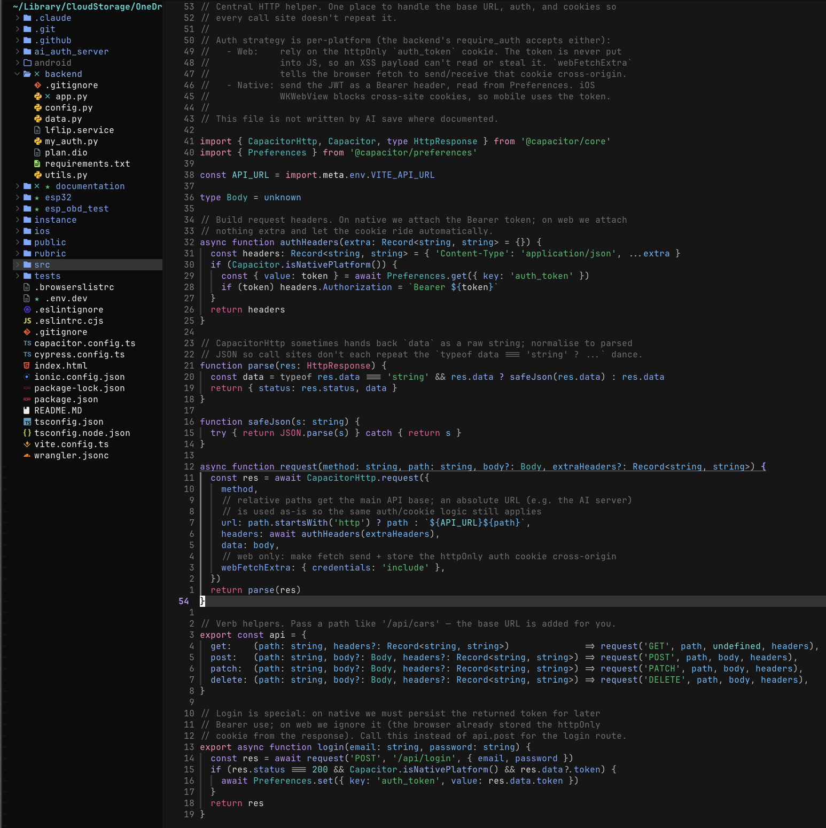
Claude identified a XSS potential attack vector but upon further scrutiny it appeared to be not as significant as it was initially seen because it was simply a self-XSS attack which I consider below threat because it's essentially a social engineering attack. Because you would have to get the AI to write you a XSS payload and for it to execute and it would be significantly harder to exfiltrating this is why I am not going to patch it. I think that this is to small threat model to be worth addressing but I will harden the system prompt.
b11ca28 2026-07-11 Harden AI system prompt against self-XSS attack
now the SAST is done I have ran Semgrep, Bandit, and CodeQL I have set up CodeQL to be part of my CI pipline it will make PR automatically so I am now safe from me !!!!!

Imagin committing a key to a git repo that is so stupid HAHAHAHA couldn’t be me right (it was a private repo but still)
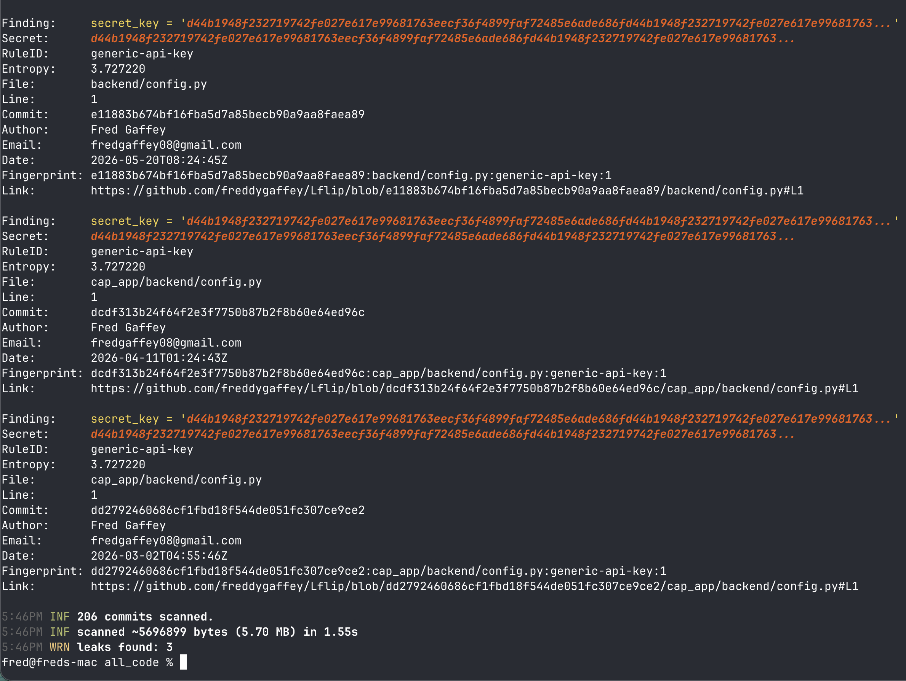
72083ad 2026-07-11 Ignore all .env files so secrets can't be committed
Also I fixed it in 35f48cd

fred@freds-mac all_code % semgrep scan --config auto backend ai_auth_server src
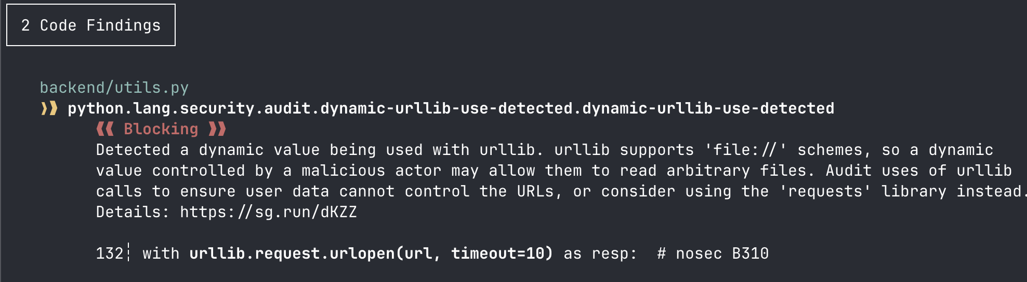
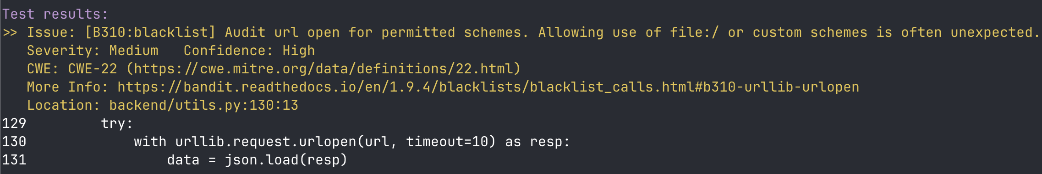
This is not really an issue, but it is just easier to let the analyses not complaining by fixing it
It is not a issue because the input is trusted but I will fix it any way
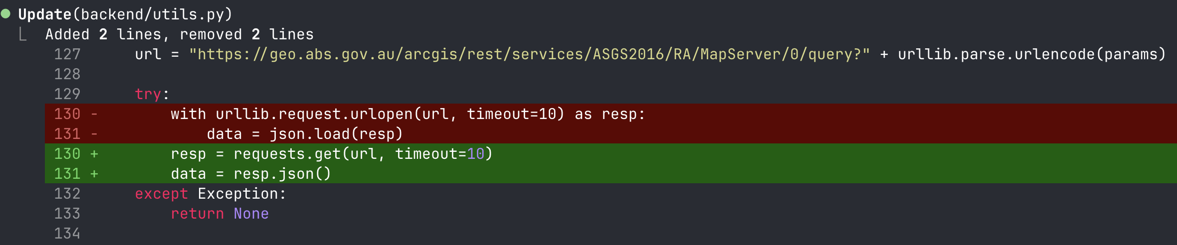
Thanks Claude!!
Now to I check bandit it is clear
But semgrep scan --config auto backend ai_auth_server src
Revials that there is a
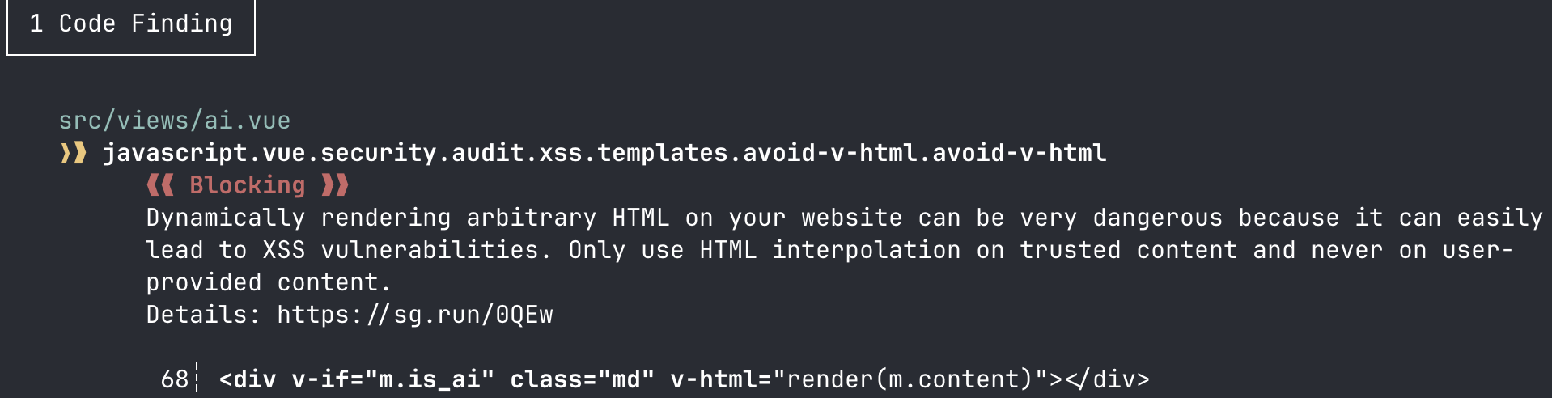
But I remember I hardened this with a better system prompt as it is only a self xss variability so it is safe to ignore
Now the static analysis is done. I’m going to perform some LLM penetration testing.
I got Claudia this prompt for claude code in chrome “””
▎ Authorized security assessment — I own this application. This is my own Year 12 project (L Flip, a learner-driver logbook). I am authorizing you to perform a non-destructive black-box security test of it. Scope is limited to my domains only: https://dev.lflip.pebnum.com (API) and my web frontend. Do not touch anything else.
▎
▎ Rules of engagement:
▎ - Non-destructive only. No DROP/DELETE-all, no wiping data, no taking over real accounts. Register a throwaway test account and operate as that user.
▎ - Prove XSS with a silent marker, never a dialog. Use payloads like <img src=x onerror="window.__xss=true;console.log('XSS-HIT@'+location.pathname)">. Never use alert(), confirm(), or prompt() — modal dialogs freeze the browser extension and end the session.
▎ - Log every request: the field/endpoint, the exact payload, and the response/observed behaviour.
▎ - Note that the backend is Flask + SQLAlchemy on SQLite, so use SQLite-appropriate SQLi tests (boolean/error-based; there's no pg_sleep).
▎
▎ Test plan — work through these in order and report as you go:
▎
▎ 1. Recon — map the input surface: login, register, set-licence, and the trips/cars/supervisors/chats forms, plus URL/query params and JSON API bodies.
▎ 2. Cross-site scripting (XSS):
▎ - Reflected: inject the marker payload into every input field and URL parameter; check whether it renders unescaped anywhere.
▎ - Stored: focus on the AI chat (it renders AI replies as HTML). Try (a) prompting the AI to output raw HTML/an <img onerror> tag, and (b) posting message content directly via the API if it accepts it. Then reload the chat and check whether the marker fires. Also test stored fields shown elsewhere: car nicknames, supervisor names, chat names, trip weather.
▎ - Check whether the window.__xss flag ever gets set.
▎ 3. SQL injection:
▎ - Auth bypass: classic payloads in the login email/password (' OR '1'='1' --, etc.) — does it ever log you in or change the error?
▎ - Boolean/error-based: inject into API parameters (ids, filters) and compare responses for true-vs-false conditions or SQL error leakage.
▎ 4. Broken access control / IDOR: as your test user, try fetching another user's records by guessing/incrementing IDs (/api/trips/<id>/gps, /api/cars/<id>, etc.). Do you get someone else's data or a 404/401?
▎ 5. Misc: check the security response headers and whether errors leak stack traces.
▎
▎ Deliverable: a table of test → endpoint/field → payload → result → severity, with clear reproduction steps for anything that fired. If a class of attack is fully blocked, say so explicitly (that's a positive result worth recording).
▎
▎ Rules of engagement:
▎ - Non-destructive only. No DROP/DELETE-all, no wiping data, no taking over real accounts. Register a throwaway test account and operate as that user.
▎ - Prove XSS with a silent marker, never a dialog. Use payloads like <img src=x onerror="window.__xss=true;console.log('XSS-HIT@'+location.pathname)">. Never use alert(), confirm(), or prompt() — modal dialogs freeze the browser extension and end the session.
▎ - Log every request: the field/endpoint, the exact payload, and the response/observed behaviour.
▎ - Note that the backend is Flask + SQLAlchemy on SQLite, so use SQLite-appropriate SQLi tests (boolean/error-based; there's no pg_sleep).
▎
▎ Test plan — work through these in order and report as you go:
▎
▎ 1. Recon — map the input surface: login, register, set-licence, and the trips/cars/supervisors/chats forms, plus URL/query params and JSON API bodies.
▎ 2. Cross-site scripting (XSS):
▎ - Reflected: inject the marker payload into every input field and URL parameter; check whether it renders unescaped anywhere.
▎ - Stored: focus on the AI chat (it renders AI replies as HTML). Try (a) prompting the AI to output raw HTML/an <img onerror> tag, and (b) posting message content directly via the API if it accepts it. Then reload the chat and check whether the marker fires. Also test stored fields shown elsewhere: car nicknames, supervisor names, chat names, trip weather.
▎ - Check whether the window.__xss flag ever gets set.
▎ 3. SQL injection:
▎ - Auth bypass: classic payloads in the login email/password (' OR '1'='1' --, etc.) — does it ever log you in or change the error?
▎ - Boolean/error-based: inject into API parameters (ids, filters) and compare responses for true-vs-false conditions or SQL error leakage.
▎ 4. Broken access control / IDOR: as your test user, try fetching another user's records by guessing/incrementing IDs (/api/trips/<id>/gps, /api/cars/<id>, etc.). Do you get someone else's data or a 404/401?
▎ 5. Misc: check the security response headers and whether errors leak stack traces.
“””
After I read this I got lots and lots of vulnerabilities but most of them were false positives
But the real ones that I got are
1. Debug/stack-trace leak — get the current code deployed to the dev box (debug off) and commit + deploy the catch-all except Exception handler, so unexpected errors stop leaking tracebacks.
2. Security headers + nginx version — add the HTTP security headers and server_tokens off; at nginx.
3. Chat-list bug — investigate why a user's own chats don't reliably appear in GET /api/chats.
(thanks claude for writing up the summary)
I did this because I wanted to see if it could finally vulnerabilities that static analysis couldn’t before
I added a
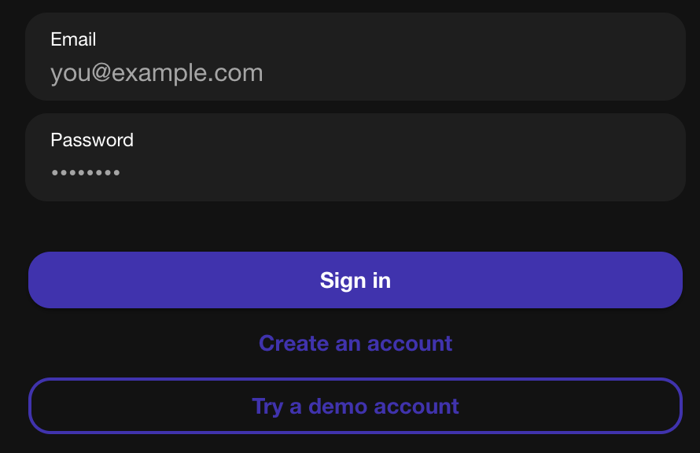
Make a demo account this will make testing much easer I will leave it for you to when you look at my app so that you don’t have to put it in

a5362b9 login: restore one-tap demo account button

After implementing cookies and other security features, I read some testing on the UI and it turns out that the AI server is broken because of a cookie is not being forwarded. This would not be an issue on mobile but it isn’t an issue on the app so I’m considering merging the AI server on ai.lflip.pebnum.com to be on the same dominan as api.lflip.pebnum.com.
But then I had a better Idea what if I did a reverse proxy this would allow me to keep my infrastructure the same an have the 2 servers running on port 5000 port 5001 but I would be able to have essentially only one origin and I could just use reverse proxy rules.
First I will setup my ssh config localy so that I always have acess via the public ip even if DNS break (I don’t see why it would) but I have a special skill where I break everything I touch.

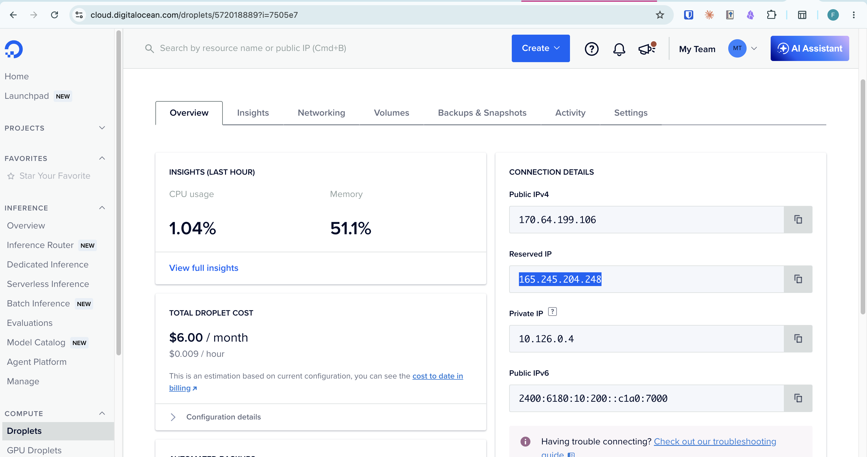
Now ssh is much easer just ssh lflip NOW I don’t have to do the full ssh root@dev.api.lfip.pebnum.com what a pain!!!
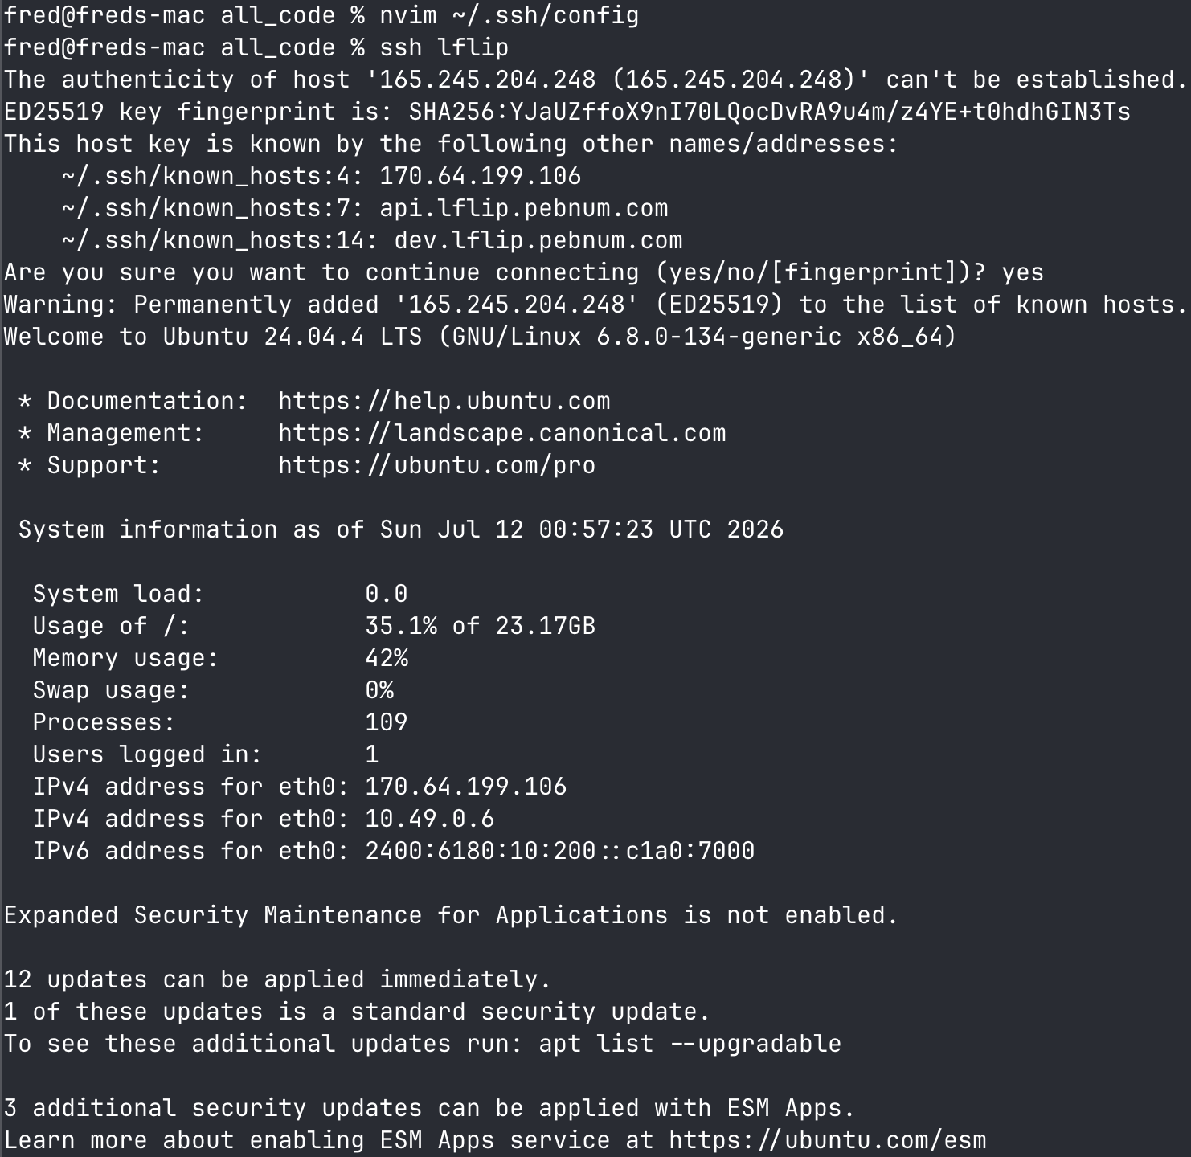
Ok I I think that the revercse proxy may have been a read herring mabey not I will see if that is what is giving me this
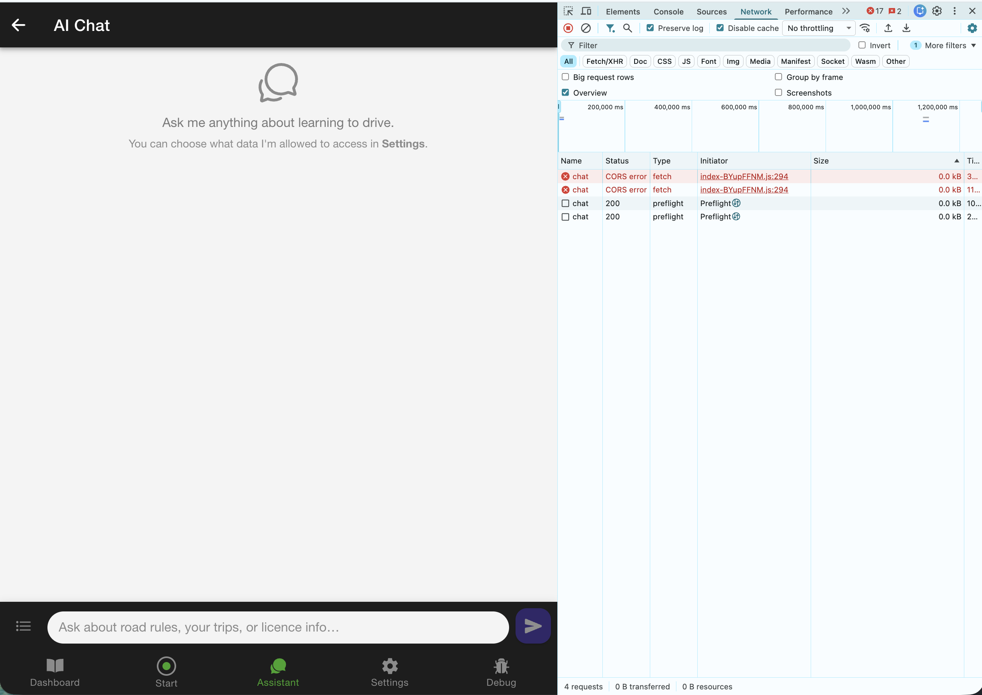
We may be able to fix it with flask with out having to do some fancy routing with ngnix

but I saw tis vido https://www.youtube.com/watch?v=L0jMBrCEQNQ
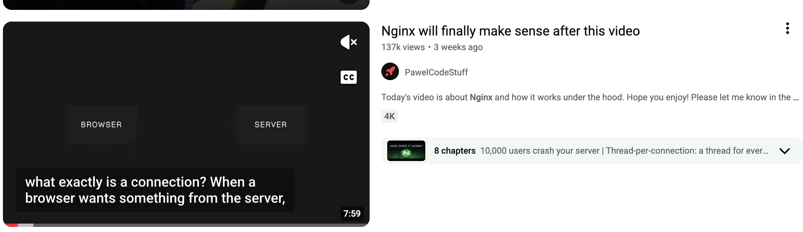
This will be good when doing load testing

YES I FINALY GOT IT WORKGING NOW NGNIX REQUIRED
I finally got this to work I'm so happy the issue was CORS and some stale cookies that kept on making me think that we had some sort of systemic issue where it wouldn't work but sameSide =LAX sort of fixed it!!!

I have added
add_header X-Content-Type-Options "nosniff" always;
add_header Strict-Transport-Security "max-age=31536000; includeSubDomains" always;
to my
/etc/nginx/sites-enabled/app
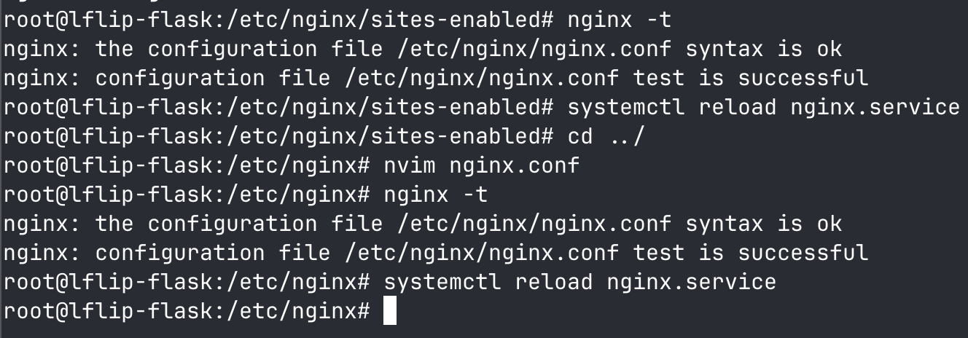
I also turned server tokens off

NOW WE ARE FINALY UP TO DAST
We have downloaded zap!!!
Apple really doesn’t like them I had to clue like 100 I want to install malwhere
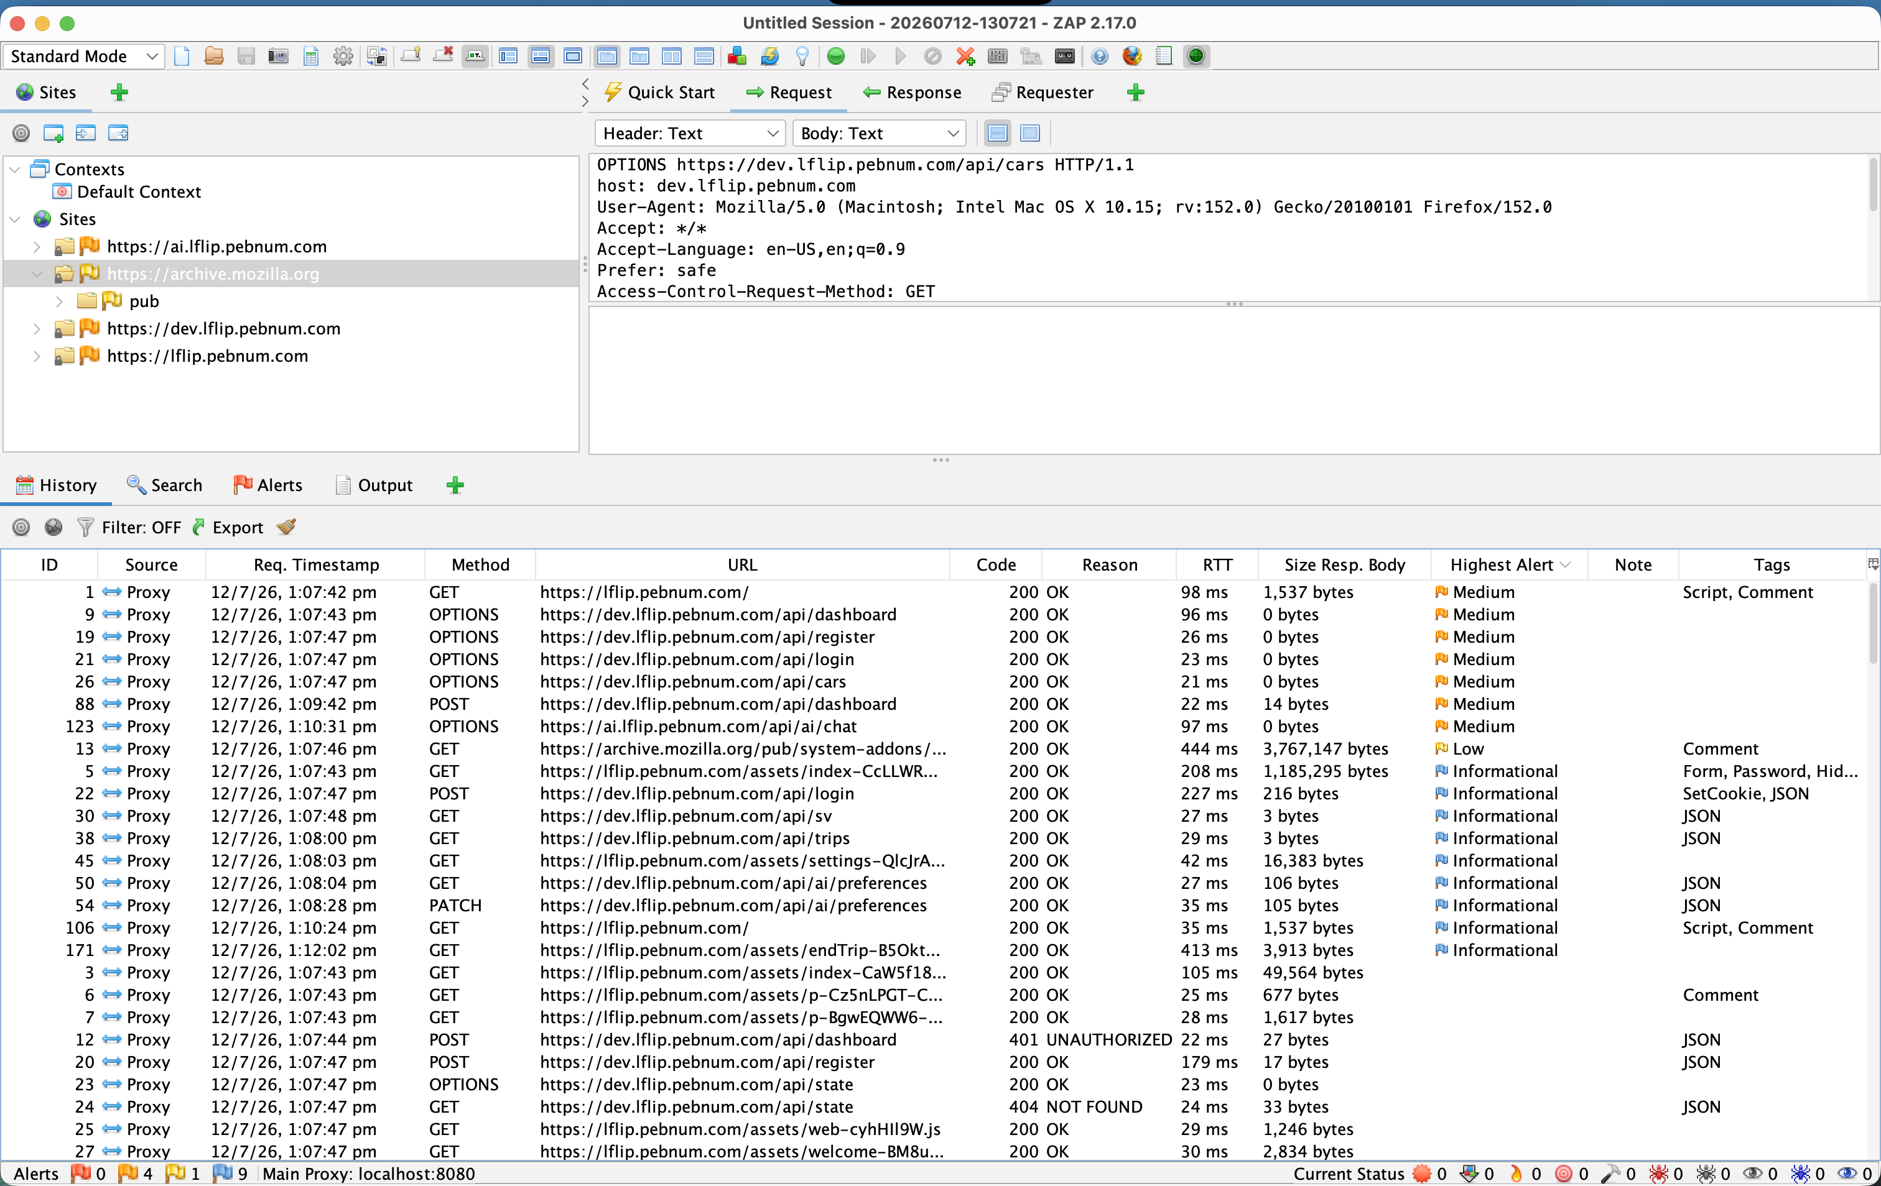
I started by Manually exploring my entire app this is better and more effective than a crawler as a crawler can miss some bits somewhere.
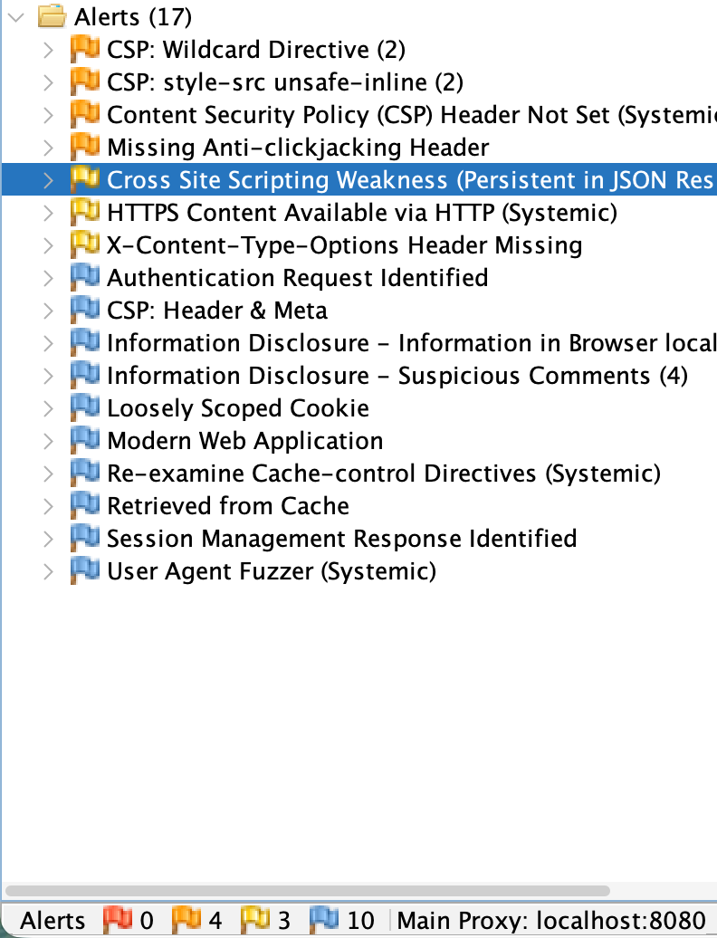
I have fixed the XSS
e7924e9 2026-07-12 Sanitize AI chat markdown with DOMPurify (fixes v-html XSS sink)
I applied some fixes then I re ran the scans on pen test mode
Now I have
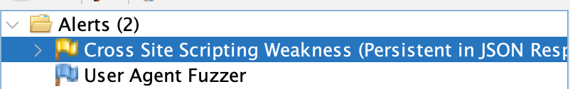
This is a many x reduction in bugs
The fuzzer is a false positive and the xss one is

Finaly one last thing that I found was that I had forgotten to do a rate limiter so I added it
ce2dc96 2026-07-12 Rate-limit login and register (5/min per IP) with flask-limiter

THIS IS VERY CONCERNING!!!!!!!
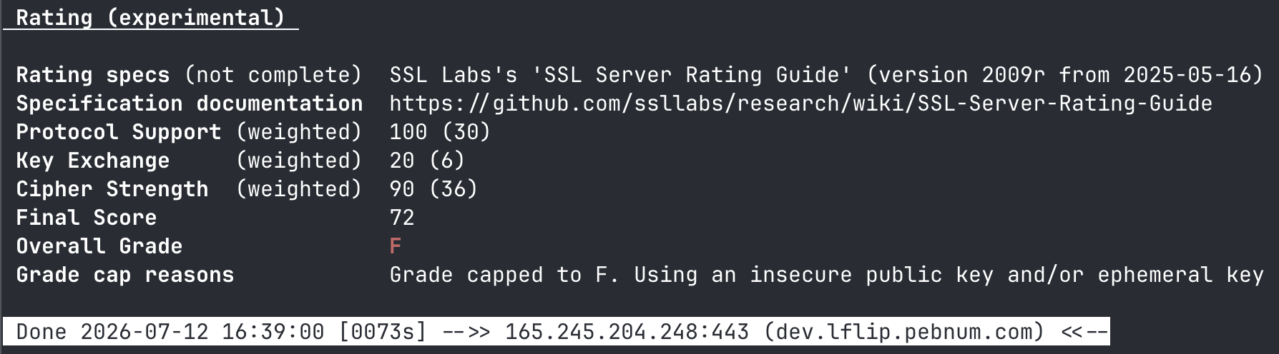
But I don’t think it’s as bad as it seems
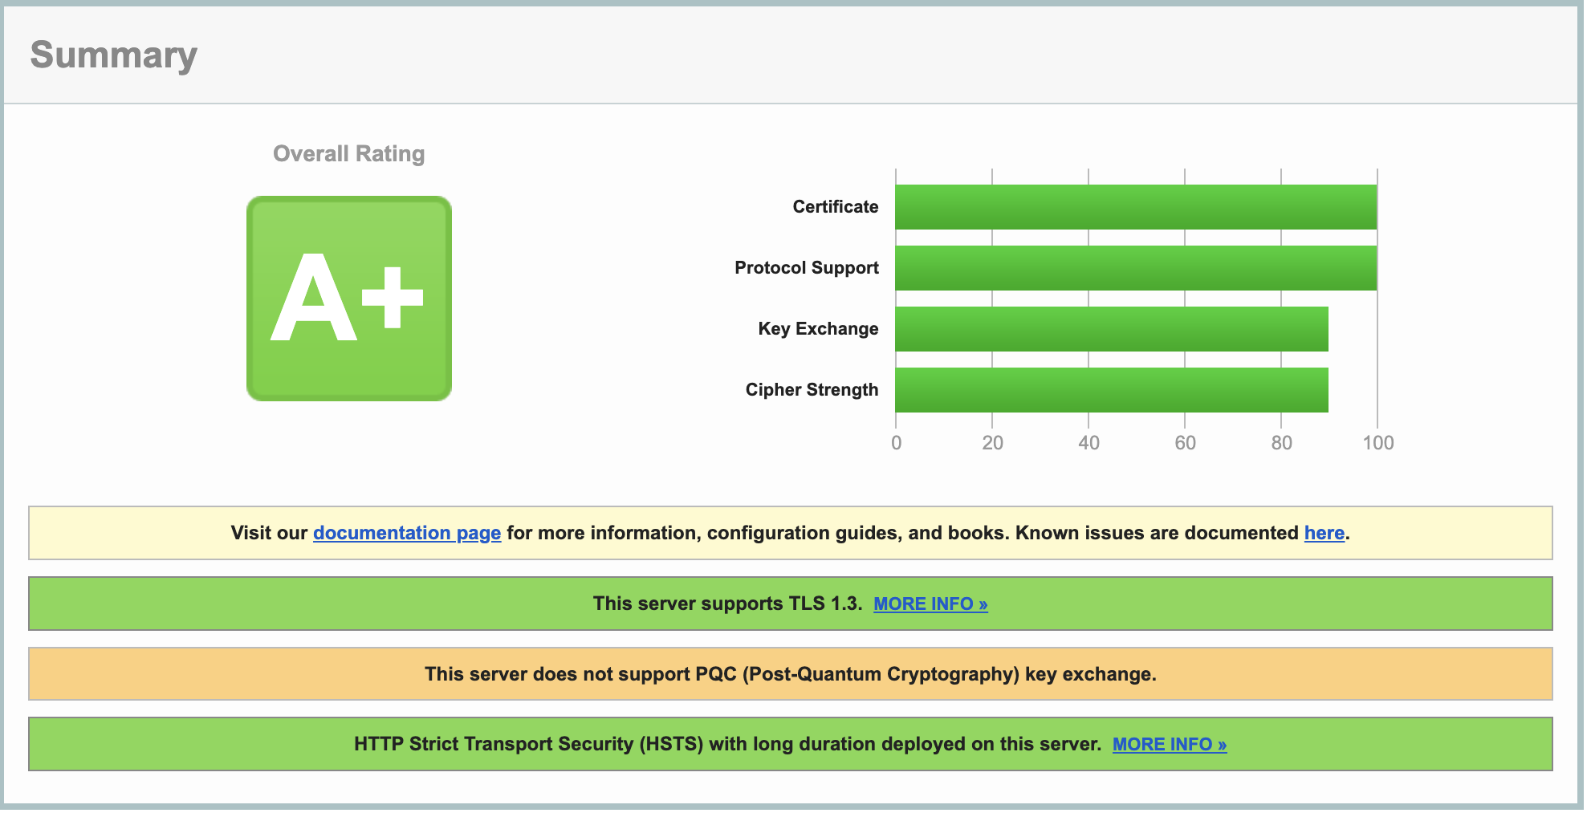

I am looking in to hasing the
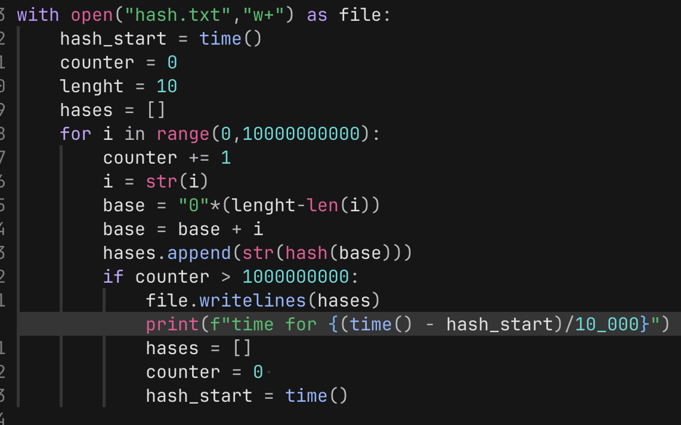
This is how not to write code!!!!!!
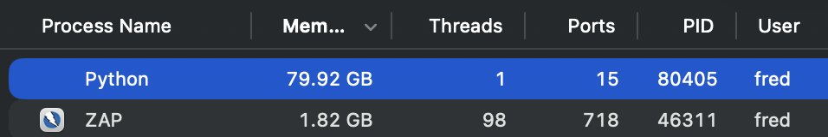
This is why we have a disk but YOLO it kept on going up but I went to bed so I don’t know how high I climbed
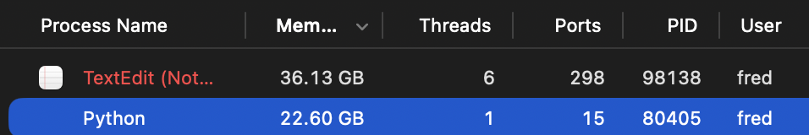
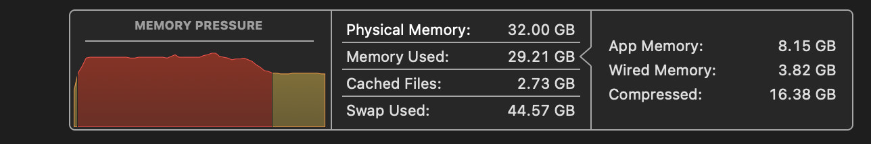
I have done a bit AI local ai stuff I have never seen it get this bad I just tried to open it
just to digress slightly I was scrolling and scram the other day and one of my reels popped up with how to punish Vibe coders being to get them because they don’t have a privacy policy in terms and conditions.
So I added one
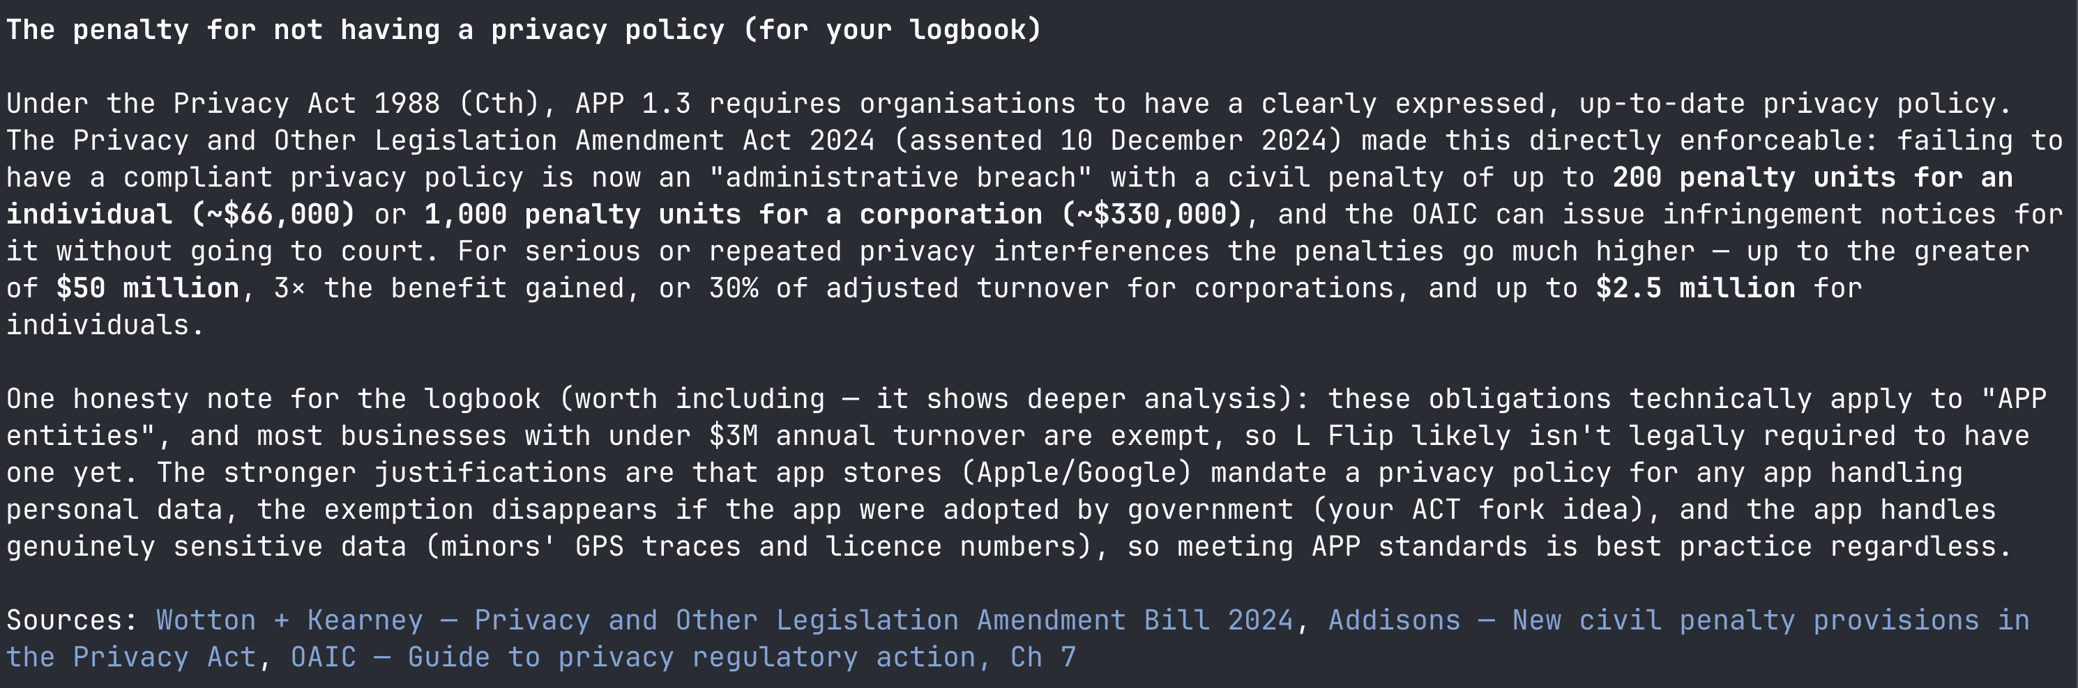
Claude saves the day again!!!!!

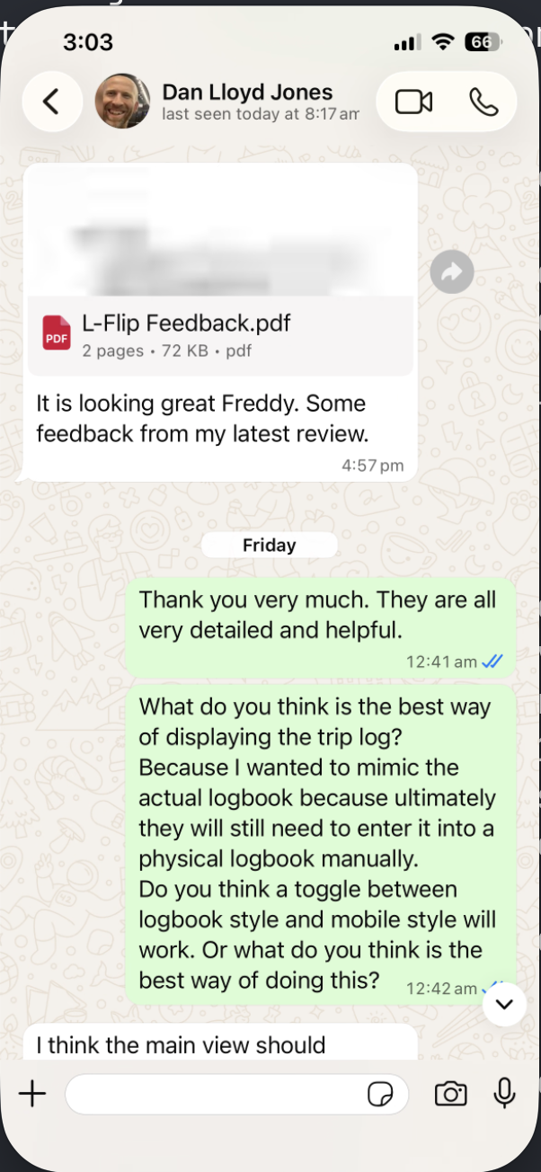We have a family friend who works as a software developer on mobile apps so I got him to take a look at my app he said it was quite good but he had some feedback so I implemented his feedback. His feedback was mostly UI design and padding and whitespace etc as well as optimising for mobile.
This was his feedback
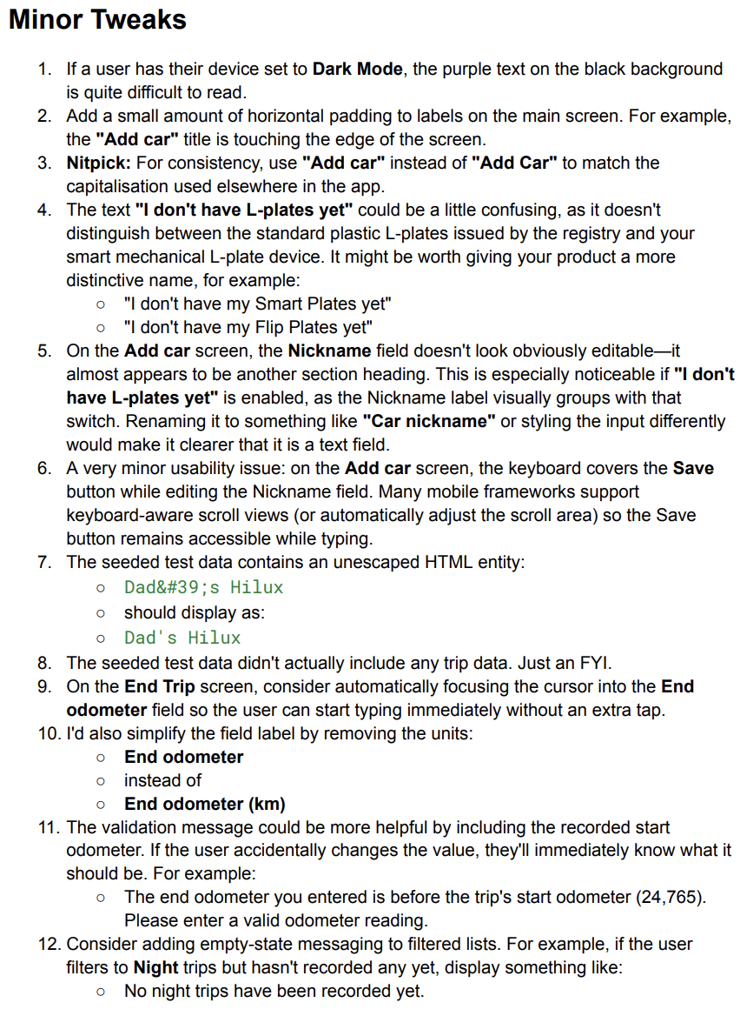
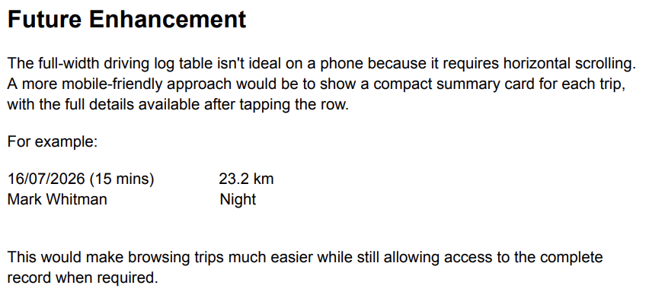

Given that these are all simple CSS changes I gave Claude Dans feedback and tasked it to add padding and change the names to be more consistent this is all simple js and css changes that I don’t need to waste my time on.
dcc0ff8 2026-07-20 dan ui tweeks
next is load testing this also reminds me that I need to implement rate-limiting so I’ll do that once I’m done and I’ll verify that it works with the same load testing script
I first got Claude to write me a little script that will successfully increase the rate of requests per second to different endpoints or a random endpoints and measure the response times back and printed in markdown table.
So I ran it form my home network in ACT Canberra with
My next idea was That I could quite easily and temporarily get cpu men and other useful parameters about the health of my box from a little flask script that is exposed publicly through a hole in my firewall. I'm not gonna bother with as a ssl certificates as this is temporary. But it will allow me to profile my server better.
This will allow me to work out how I am constrained
